**Supporting Information**

**Title**

Authors listed here

*Affiliations listed here*

* E-mail: henri.xhaard@helsinki.fi. Tel. +358-2941-59190.

**Table of Contents**

**1. Structural and biological overview of all compounds (Figure S1)** 3

**2. Aggregation data for §4, §11l and §11m (Figure S2)** 4

**3. Inhibition curves for §4**, **§11l** and **§11m (Figure S3)** 5

**4. Experimental procedures and characterization data**  6

**4. NMR spectra for XX–XX**, **XX–XX and XX–XX, More to be added…** 38

**5. Mass spectra for ???** 58

**6. KNIME workflow** 75

**X. References** 75

# **1. Structural and biological overview of all compounds (Figure S1)**

XXX

Figure S1: All compounds tested for this story (structures in 2D + pre-IC50)



# **2. Aggregation data for §4, §11l and §11m (Figure S2)**

Potential aggregation in the TmPPase based assay was studied at five concentrations (50 μM, 25 μM, 10 μM, 5 μM, and 1 μM). The assay conditions were mimicked and the light scattering of any particles/aggregates in the mixture was studied by nephelometric methods using a Nepheloskan Ascent® (Labsystems, Finland). Aggregation of the blank and compounds **§4**, **§11l** and **§11m** were measured as triplicates from one independent experiment at three different voltages (300 V, 400 V, 500 V) at room temperature. For compound **§4** there was no detectable aggregation at all. Compounds **§11l** and **§11m** showed definite aggregate formation at both 50 μM and 25 μM. However, at 10 μM, 5 μM and 1 μM concentrations the obtained values were close to those observed by the blank, thereby indicating only minor/no detectable aggregation.



Figure S2. Aggregation data for compounds **§4**, **§11l** and **§11m**. The data (measured in RNU *i.e.* relative nephelometric unit) is shown as the mean ± SD and normalized to the blank.

# **3. Inhibition curves for §4**, **§11l** and **§11m (Figure S3)**



**NJ1-58**

pIC50 = 5.16 ± 0.021

IC50 = 6.89 ± 0.326 μM

**MTI61**

pIC50 = 4.78 ± 0.010

IC50 = 16.71 ± 0.400 μM

**NJ1-59**

pIC50 = 5.01 ± 0.034

IC50 = 9.83 ± 0.771 μM







Figure S3. TmPPase inhibition curve (IC50 for the top 3 compounds: **§4**, **§11l** and **§11m**)

# **4. Experimental procedures and characterization data**

All chemicals used were commercially available. Reactions using anhydrous conditions were conducted in oven-dried (130 °C, >24 h) glassware and purged with argon prior to use. Microwave reactions were performed using a Biotage Initiator+ SP Wave Microwave Synthesizer (Uppsala, Sweden). The progress of the reactions was monitored by thin-layer chromatography on silica gel 60-F254 aluminum plates and visualized by using a dual short/long wave (254/366 nm) UV lamp. Combined organic solutions from extractions were dried over anhydrous Na2SO4, filtered and concentrated with a rotary evaporator at low pressure. Flash SiO2 column chromatography was performed with an automated high performance flash chromatography Biotage Isolera™ Spektra Systems with ACI™ and Assist (ISO-1SW Isolera One) equipped with a variable UV-VIS (200–800 nm) photodiode array (Uppsala, Sweden), SNAP KP-SIL/Ultra 10 g or 25 g cartridges and the indicated mobile phase gradient. The reactions were not optimized and all the yields are given for purified products.

Characterization of the synthesized products were done by NMR and MS analysis. 1H and 13C NMR spectra were acquired at 298 K on a Bruker Ascend 400 MHz – Avance III HD NMR spectrometer (Bruker Corporation, Billerica, MA, USA). Chemical shifts (*δ*) are reported in parts per million (ppm) relative to the residual NMR solvent signals (CDCl3: *δ*H = 7.26 and *δ*C = 77.16 ppm; CD3OD: *δ*H = 3.31 and *δ*C = 49.00 ppm; DMSO-*d*6: *δ*H = 2.50 and *δ*C = 39.52 ppm;) or the internal standard trimethylsilane, TMS (*δ*H = *δ*C = 0.00 ppm). Multiplicities are indicated as s (singlet), d (doublet), t (triplet), q (quartet), dd (doublet of doublets) and m (multiplet). Purity of the final compounds (>95%) was confirmed by LC-MS using a Waters Acquity® UPLC system (Waters, Milford, MA, USA) attached to an Acquity PDA detector and a Waters Synapt G2 HDMS mass spectrometer (Waters, Milford, MA, USA) equipped with an Acquity UPLC® BEH C18 column (1.7 μm, 50 × 2.1 mm, Waters, Ireland). Mass range was set from 100 to 600 Da. High resolution mass (HRMS-ESI) data was reported for the calculated and experimentally found molecular ions [M+H]+ or [M−H]−.

The isoxazole core was mainly constructed by two different routes (General procedures A or B), followed by hydrolysis (General procedure C) to give isoxazole 3-carboxylic acids. Some compounds were also subsequently esterified (General procedure D).

***Formation of isoxazoles***

**General procedure A** *– [3 + 2] cycloaddition* (compounds **§9b–d** and **§9l–o**)



Ethyl-2-chloro-2-(hydroxymino)acetate (2 equiv, except for **9o** that required 4 equiv), sodium bicarbonate (2 equiv, except for **9o** that required 4 equiv), alkyne **§6** (1 equiv, *solid/liquid* alkynes added *before/after* the solvent, respectively) and anhydrous acetonitrile (10–20 mL) was magnetically stirred at room temperature for several days. The resulting mixture was evaporated to dryness and subsequently purified by Biotage Isolera flash chromatography with TLC gradient estimation and a 10–25 g SNAP KP-Sil cartridge with hexane:ethyl acetate (1:0 → 0:1) as the eluent. This provided a yield of 57–100% of the obtained product as a whitish solid.

**General procedure B** *– Claisen condensation and subsequent cyclization utilizing hydroxylamine or hydrazine* (compounds **§9a**, **§9e–g**, **§9i–k**, **§S12** and **§S14**)



*Step 1)*

*Claisen condensation* (compounds **§9e–g**, **§9i–k**, **§S12** and **§S14**). A freshly prepared solution of sodium ethoxide (2–4 mL, 1 equiv) was diluted with anhydrous diethyl ether (20–50 mL). To this solution was subsequently added diethyl oxalate (1 equiv) and arylketone **§7** (1 equiv), which were allowed to react at room temperature overnight. The resulting mixture was either extracted with water (3 × 10 mL) or alternatively dissolved in water (50–100 mL). The combined aqueous phases were acidified with glacial acetic acid and the formed precipitate was filtered off and dried under reduced pressure. This provided 47–69% of the arylbutanoate product as a yellow or off-white solid that was used in the next step without further purifications.

*Step 2)*

*Cyclization utilizing hydroxylamine* (compounds **§9a**, **§9e–g** and **§9i–k**). Arylbutanoate (1 equiv) and hydroxylamine hydrochloride (1 equiv) was dissolved in ethanol (20 mL) and refluxed at 80 °C for 3 hours. The solvent was evaporated and the residue was purified by Biotage Isolera flash chromatography with TLC gradient estimation and a 25 g SNAP KP-Sil cartridge with hexane:ethyl acetate (1:0 → 0:1) as the eluent. This provided 52–86% of the formed isoxazole as a white solid.

*Cyclization utilizing hydrazine* (compounds **§S12** and **§S14**). To a solution of arylbutanoate (1 equiv) in ethanol (2 mL) was added glacial acetic acid (1 equiv) and hydrazine hydrate (1 equiv). The solution was stirred at room temperature for 5 hours. The reaction mixture was diluted with aqueous NaHCO3 (10 mL), extracted with EtOAc (3 × 15 mL), dried with Na2SO4, filtered, evaporated and the residue was purified by Biotage Isolera flash chromatography with TLC gradient estimation and a 10 g SNAP KP-Sil cartridge with hexane:ethyl acetate (1:0 → 0:1) as the eluent. This provided 82–86% of the formed pyrazole as a white solid.

***Formation of isoxazole 3-carboxylic acids***

**General procedure C** *– Hydrolysis of ethyl ester* (compounds **§10a–o**, **§12** and **§14**)



The ethyl ester (1 equiv) and lithium hydroxide (2equiv, except for **10b–d** and **10o** that required 4 equiv) was dissolved in a mixture of ethanol and water (2:1). The mixture was magnetically stirred at room temperature for one hour to two days until completion. The mixture was diluted with water (5–10 mL). Depending on the water solubility of the salts, the easily soluble ones were washed with EtOAc (3 × 5–15 mL) whereas the hardly water soluble salts were not, before acidification using 1 M hydrochloric acid. The product was extracted with EtOAc (3 × 5–15 mL), dried with Na2SO4, evaporated and was dried *in vacuo* overnight.

***Formation of 2-bromophenyl isoxazole-3-carboxylates***

**General procedure D** *– Esterification of carboxylic acids* (compounds **§11i–m** and **§20**)



To the carboxylic acid (1 equiv) was dropwise added a solution of oxalyl chloride (1.2 equiv) in DCM (1 mL) and a catalytic amount of anhydrous DMF. The mixture was allowed to stir for 30–60 min before it was bubbled with argon for 5 min. The formed acid chloride was cooled to 0 °C in an ice bath. To the cooled solution was during ten minutes added 2-bromophenol (1.2 equiv) in DCM (0.75 mL), followed by triethylamine (1.2 equiv) in DCM (0.75 mL). The mixture was stirred for 20 min in the ice bath and another 30 min at room temperature (~1 hour since the phenol addition). The solvent was evaporated and the residue was purified by Biotage Isolera flash chromatography with TLC gradient estimation and a 10 g SNAP KP-Sil cartridge with hexane:ethyl acetate (1:0 → 0:1) as the eluent. This provided 57–82% of the formed ester as a white solid.

**5-(2-Methylthiazol-4-yl)isoxazole-3-carboxylic acid (§4).** Purchased from Sigma (*CDS018284*). MTI61 1H NMR (400.15 MHz, DMSO-*d6*) *δ* = 8.28 (s, 1H), 7.08 (s, 1H), 2.73 (s, 3H). 13C NMR (100.63 MHz, DMSO-*d6*) *δ* = 167.8, 166.3, 160.7, 157.7, 141.3, 120.7, 101.2, 18.8. HRMS-ESI (*m*/*z*): calculated for C8H7N2O3S [M+H]+ 211.0177; found, 211.0179.

**_:_:_:_:_:_:_:_:_:_:_:_:_:_:_:_:_:_:_:_:**

**5-(1,5-Dimethyl-1*H*-pyrazol-4-yl)isoxazole-3-carboxylic acid (§5).** Purchased from Sigma (*CDS016293*). MTI59 1H NMR (400.15 MHz, DMSO-*d6*) *δ* =. 13C NMR (100.63 MHz, DMSO-*d6*) *δ* = . HRMS-APCI (*m*/*z*): calculated for C9H8N3O3 [M−H]− 206.0567; found, 206.0566.

**2-(4-Nitrophenyl)-1,3-thiazole-4-carboxylic acid** **(§15).** Purchased from Ambinter (*Amb2420928*). Amb928 1H NMR (400.15 MHz, DMSO-*d6*) *δ* =. 13C NMR (100.63 MHz, DMSO-*d6*) *δ* = . HRMS-ESI (*m*/*z*): calculated for C10H7N2O4S [M+H]+ 251.0126; found, 251.0127.

*****N*-(Benzo[*d*]thiazol-2-yl)-3,5-di-*tert*-butylbenzamide (§16).** Purchased from Ambinter (*Amb1196838*). Amb838 1H NMR (400.15 MHz, DMSO-*d6*) *δ* =. 13C NMR (100.63 MHz, DMSO-*d6*) *δ* = . HRMS-ESI (*m*/*z*): calculated for C22H27N2OS [M+H]+ 367.1844; found, 367.1844.

 ***N*-(2-Bromophenyl)-3,5-di-*tert*-butylbenzamide (§17).** Purchased from Ambinter (*Amb2678486*). Amb486 1H NMR (400.15 MHz, DMSO-*d6*) *δ* =. 13C NMR (100.63 MHz, DMSO-*d6*) *δ* = . HRMS-ESI (*m*/*z*): calculated for C21H27BrNO [M+H]+ 388.1276; found, 388.1273.

 **3,5-Di-tert-butyl-*N*-(4-nitrophenyl)benzamide (§18).** Purchased from Ambinter (*Amb6452717*). Amb717 1H NMR (400.15 MHz, DMSO-*d6*) *δ* =. 13C NMR (100.63 MHz, DMSO-*d6*) *δ* = . HRMS-ESI (*m*/*z*): calculated for C21H27N2O3 [M+H]+ 355.2022; found, 355.2024.

**Ethyl 5-(3-(*N*-(benzo[*d*][1,3]dioxol-4-yl)sulfamoyl)-4-methoxyphenyl)isoxazole-3-carboxylate (§19).** Purchased from Ambinter (*Amb16561898*). Amb898 1H NMR (400.15 MHz, DMSO-*d6*) *δ* =. 13C NMR (100.63 MHz, DMSO-*d6*) *δ* = . HRMS-ESI (*m*/*z*): calculated for C20H19N2O8S [M+H]+ 447.0862; found, 447.0870.

-.-.-.-.-.-.-.-.-.-.-.-.-.-.-.-.-.-.-.-.-.-.-.-.-.-.-.-.-.-.-.-.-.-.-.-.-

Synthesized/Purchased from, XX according to General procedure XX

**Ethyl 5-phenylisoxazole-3-carboxylate (§9a).** To a freshly prepared solution of sodium ethoxide (5 mL, 154 mg, 6.7 mmol, 2 equiv) was at 50 °C added a solution of acetophenone (0.39 mL, 3.3 mmol, 1 equiv) and diethyl oxalate (0.90 mL, 6.6 mmol, 2 equiv) in ethanol (3 mL). The mixture was stirred for 2 hours at 80 °C before the solvent was evaporated. The remaining residue was stirred for 1 hour in 1 M HCl (6 mL), followed by extraction with EtOAc (3 × 10 mL). The product was washed with water (10 mL), dried with Na2SO4, evaporated and dried *in vacuo* overnight. The obtained orange oil (quantitative yield) was used without further purifications in the next step. General procedure B, Step 2 (*cyclization utilizing hydroxylamine*) was followed using ethyl 2-hydroxy-4-oxo-4-phenylbut-2-enoate (101 mg, 0.46 mmol, 1 equiv). In this case the reaction time was 2 hours to give **§9a** as a white solid (81 mg, 80% *after two steps*). NJ1-19 1H NMR (400.15 MHz, DMSO-*d6*) *δ* =. 13C NMR (100.63 MHz, DMSO-*d6*) *δ* = . HRMS-ESI (*m*/*z*): calculated for C12H12NO3 [M+H]+ 218.0817; found, 218.0817.

**Ethyl 5-(2-(methoxycarbonyl)phenyl)isoxazole-3-carboxylate (§9b)**. General procedure A was followed using methyl 2-ethynylbenzoate (128 mg, 0.80 mmol, 1 equiv). In this case the reaction time was 136 hours to give **§9b** as a yellow oil that later on formed a whitish solid (130 mg, 0.47 mmol, 59%). DAP-14 1H NMR (400.15 MHz, CDCl3) *δ* = 7.92–7.88 (m, 1 H), 7.64–7.60 (m, 2H), 7.60–7.54 (m, 1H), 6.87 (s, 1H), 4.47 (q, *J* = 7.1, 2H), 3.84 (s, 3H), 1.43 (t, *J* = 7.1 Hz, 3H). 13C NMR (100.63 MHz, CDCl3) *δ* = 170.9, 167.0, 159.7, 156.4, 131.7, 130.7, 130.5, 130.2, 129.8, 126.4, 103.1, 62.0, 52.5, 14.0. No ref values HRMS-ESI (*m*/*z*): calculated for C14H14NO5 [M+H]+ 276.0872; found, 276.0873.

**Ethyl 5-(3-(methoxycarbonyl)phenyl)isoxazole-3-carboxylate (§9c).** General procedure A was followed using methyl 3-ethynylbenzoate (109 mg, 0.68 mmol, 1 equiv. In this case the reaction time was 72 hours, to give **§9c** as a whitish solid (166 mg, 0.60 mmol, 88%).DAP-02 1H NMR (400.15 MHz, CDCl3) *δ* =. 13C NMR (100.63 MHz, CDCl3) *δ* = . HRMS-ESI (*m*/*z*): calculated for C14H14NO5 [M+H]+ 276.0872; found, 276.0873.

1H NMR (400 MHz, Chloroform-*d*): δ (in ppm) 8,48–8,45 (s, 1H), 8,17–8,13 (ddd, J=7,8; 1,2 Hz, 1H), 8,02 (ddd, J=7,8; 1,2 Hz, 1H), 7,60 (t, J=8,0 Hz, 1H), 7,02 (s, 1H), 4,49 (q, J=7,1 Hz, 2H), 1,45 (t, J=7,1 Hz, 3H).

**Ethyl 5-(4-(methoxycarbonyl)phenyl)isoxazole-3-carboxylate (§9d).** General procedure A was followed using methyl 4-ethynylbenzoate (55 mg, 0.34 mmol, 1 equiv). In this case the reaction time was 90 hours, to give **§9d** as a whitish solid (38 mg, 0.14 mmol, 41%). DAP-07/(17) 1H NMR (400.15 MHz, CDCl3) *δ* =. 13C NMR (100.63 MHz, CDCl3) *δ* = . HRMS-ESI (*m*/*z*): calculated for C14H14NO5 [M+H]+ 276.0872; found, 276.0874.

1H NMR (400 MHz, Chloroform-*d*) δ 8.22 – 8.11 (m, 2H), 7.93 – 7.85 (m, 2H), 7.03 (s, 1H), 4.49 (q, *J* = 7.1 Hz, 2H), 3.96 (s, 3H), 1.45 (t, *J* = 7.1 Hz, 3H).

13C NMR (101 MHz, CDCl3) δ 170.50, 166.13, 159.78, 157.12, 132.00, 130.40, 130.30, 125.86, 101.38, 62.40, 52.46, 14.18.

1H NMR (400.15 MHz, CDCl3) *δ* = 8.18–8.14 (m, 2H), 7.91–7.87 (m, 2H), 7.03 (s, 1H), 4.49 (q, *J* = 7.2 Hz, 2H), 3.96 (s, 3H), 1.45 (t, *J* = 7.1 Hz, 3H). 13C NMR (100.63 MHz, CDCl3) *δ* = 170.6, 166.3, 159.9, 157.3, 132.1, 130.5, 130.4, 126.0, 101.5, 62.5, 52.6, 14.3. No ref values

**Ethyl 5-(2-methoxyphenyl)isoxazole-3-carboxylate (§9e).** General procedure B was followed, using 2’-methoxyacetophenone (963 mg, 6.4 mmol, 1 equiv) to give **§9e** as a whitish solid (430 mg, 1.7 mmol, 59% *after two steps*). DAP-18 1H NMR (400.15 MHz, CDCl3) *δ* =. 13C NMR (100.63 MHz, CDCl3) *δ* = . HRMS-ESI (*m*/*z*): calculated for C13H14NO4 [M + H]+ 248.0923; found 248.0926.

1H NMR (400.15 MHz, CDCl3) *δ* = 8.00 (dd, *J* = 7.8, 1.7 Hz, 1H), 7.47–7.40 (m, 1H), 7.17 (s, 1H), 7.11–7.05 (m, 1H), 7.02 (app d, *J* = 8.4 Hz, 1H), 4.47 (q, *J* = 7.2 Hz, 2H), 3.98 (s, 3H), 1.44 (t, *J* = 7.1 Hz, 3H). 13C NMR (100.63 MHz, CDCl3) *δ* = 167.9, 160.6, 157.1, 156.4, 132.0, 127.8, 121.0, 115.8, 111.4, 104.0, 62.2, 55.7, 14.3.REFA. Tourteau *et al*./Bioorg.Med.Chem. 21 (2013) 5383–5394

**Ethyl 5-(3-methoxyphenyl)isoxazole-3-carboxylate (§9f).** General procedure B was followed, using 3’-methoxyacetophenone (963 mg, 6.4 mmol, 1 equiv) to give **§9f** as a whitish solid (197 mg, 0.80 mmol, 20% *after two steps*). DAP-16 1H NMR (400.15 MHz, CDCl3) *δ* =. 13C NMR (100.63 MHz, CDCl3) *δ* = . HRMS-ESI (*m*/*z*): calculated for C13H14NO4 [M + H]+ 248.0923; found 248.0926.

**Ethyl 5-(4-methoxyphenyl)isoxazole-3-carboxylate (§9g).** General procedure B was followed, using 4’-methoxyacetophenone (976 mg, 6.5 mmol, 1 equiv) to give **§9g** as a white solid (215 mg, 0.88 mmol, 28% after two steps). DAP-04/08/10 1H NMR (400.15 MHz, CDCl3) *δ* =. 13C NMR (100.63 MHz, CDCl3) *δ* = . HRMS-ESI (*m*/*z*): calculated for C21H27BrNO [M+H]+ 388.1276; found, 388.1273.



**Ethyl 5-(4-cyanophenyl)isoxazole-3-carboxylate (§9h).** The title compound was synthesized applying a previously reported method. [REF Grob]

General procedure C was used to give **§9h** as a white solid (43 mg, 89%). NJ1-2/3 1H NMR (400.15 MHz, DMSO-*d6*) *δ* =. 13C NMR (100.63 MHz, DMSO-*d6*) *δ* = . HRMS-ESI (*m*/*z*): calculated for C13H11N2O5 [M+H]+ 243.0770; found, 243.0769.

**Ethyl 5-(4-nitrophenyl)isoxazole-3-carboxylate (§9i).** General procedure B was followed using 4’-nitroacetophenone (1.97 g, 12 mmol, 1 equiv) to give **§9i** as a white solid (51 mg, 0.19 mmol, 30% *after two steps*). (DAP-22)/NJ2-4 1H NMR (400.15 MHz, CDCl3) *δ* =. 13C NMR (100.63 MHz, CDCl3) *δ* = . HRMS-ESI (*m*/*z*): calculated for C12H11N2O5 [M+H]+ 263.0668; found, 263.0670.

1H NMR (400.15 MHz, CDCl3) *δ* = 8.39–8.34 (m, 2H), 8.02–7.97 (m, 2H), 7.11 (s, 1H), 4.49 (q, *J* = 7.1 Hz, 2H), 1.45 (t, *J* = 7.1 Hz, 3H). 13C NMR (100.63 MHz, CDCl3) *δ* = 169.2, 159.6, 157.4, 149.0, 132.0, 126.9, 124.7, 102.6, 62.7, 14.3. J. Zhao et al. / Bioorg. Med. Chem. Lett. 24 (2014) 2802–2806 XXXXX

**Ethyl 5-(3-methylphenyl)isoxazole-3-carboxylate (§9j).** General procedure B was followed using 3’-methylacetophenone (504 mg, 3.8 mmol, 1 equiv) to give **§9j** as a white solid (272 mg, 1.2 mmol, 80% *after two steps*). NJ1-77 1H NMR (400.15 MHz, CDCl3) *δ* =. 13C NMR (100.63 MHz, CDCl3) *δ* = . HRMS-ESI (*m*/*z*): calculated for C13H14NO3 [M+H]+ 232.0974; found, 232.0977.

**Ethyl 5-(3-(tert-butyl)phenyl)isoxazole-3-carboxylate (§9k).** General procedure B was followed using 3’-*t*-butylacetophenone (502 mg, 2.8 mmol, 1 equiv) to give **§9k** as a white solid (260 mg, 0.95 mmol, 77% *after two steps*).NJ1-78 1H NMR (400.15 MHz, CDCl3) *δ* =. 13C NMR (100.63 MHz, CDCl3) *δ* = . HRMS-ESI (*m*/*z*): calculated for C16H20NO3 [M+H]+ 274.1443; found, 274.1445.

**Ethyl 5-(3,5-dimethylphenyl)isoxazole-3-carboxylate (§9l).** General procedure A was followed using 1-ethynyl-3,5-dimethylbenzene (106 mg, 0.81 mmol, 1 equiv). In this case the reaction time was 80 hours, to give **§9l** as a white solid (140 mg, 0.57 mmol, 70%). NJ1-30 1H NMR (400.15 MHz, CDCl3) *δ* = 7.43 (s, 2H), 7.11 (s, 1H), 6.89 (s, 1H), 4.47 (q, *J* =7.1 Hz, 2H), 2.38 (s, 6H), 1.44 (t, *J* =7.1 Hz, 3H). 13C NMR (100.63 MHz, CDCl3) *δ* = 172.2, 160.3, 157.0, 139.0, 132.6, 126.6, 123.8, 99.9, 62.3, 21.4, 14.3. HRMS-ESI (*m*/*z*): calculated for C14H16NO3 [M + H]+, 246.1130; found, 246.1131.No ref values

**Ethyl 5-(3,5-di-*tert*-butylphenyl)isoxazole-3-carboxylate (§9m).** General procedure A was followed using 1,3-di-*tert*-butyl-5-ethynylbenzene (91 mg, 0.42 mmol, 1 equiv). In this case the reaction time was 135 hours, to give **§9m** as a colorless oil (129 mg, 0.39 mmol, 92%). NJ1-27 1H NMR (400.15 MHz, CDCl3) *δ* = 7.64 (d, *J* =1.8 Hz, 2H), 7.55 (app t, *J* = 1.8 Hz, 1H), 6.92 (s, 1H), 4.48 (q, *J* =7.1 Hz, 2H), 1.45 (t, *J* =7.1 Hz, 3H) 1.37 (s, 18H). 13C NMR (100.63 MHz, CDCl3) *δ* = 172.9, 160.3, 157.0, 152.0, 126.2, 125.3, 120.4, 99.8, 62.3, 35.2, 31.5, 14.4. HRMS-ESI (*m*/*z*): calculated for C20H28NO3 [M + H]+, 330.2069; found, 330.2068.No ref values

**Ethyl 5-(3,5-bis(trifluoromethyl)phenyl)isoxazole-3-carboxylate (§9n).** General procedure A was followed using 1-ethynyl-3,5-bis-(trifluoromethyl)benzene (92 mg, 0.39 mmol, 1 equiv). In this case the reaction time was 135 hours, to give **§9n** as a white solid (112 mg, 0.32 mmol, 82%).NJ1-28 1H NMR (400.15 MHz, CDCl3) *δ* =. 13C NMR (100.63 MHz, CDCl3) *δ* = . HRMS-ESI (*m*/*z*): calculated for C14H10F6NO3 [M+H]+ 354.0565; found, 354.0562.

**NJ1-34 1H NMR (400.15 MHz, MeOD) *δ* = 8.47 (s, 2H), 8.11 (s, 1H), 7.50 (s, 1H). 13C NMR (100.63 MHz, MeOD) *δ* = 169.6, 162.0, 159.4, 133.9 (q, *J* = 34Hz), 130.4, 127.3 (q, *J* = 4.1 Hz), 124.4 (q. *J* = 272 Hz), 125.0 (hept, *J* = 3.8 Hz), 104.0. HRMS-ESI (*m*/*z*): calculated for C12H6F6NO3 [M+H]+ 326.0252; found, 326.0248.**

**Diethyl 5,5'-(1,3-phenylene)bis(isoxazole-3-carboxylate) (§9o).** General procedure A was followed using 1,3-diethynylbenzene (200 mg, 1.6 mmol, 1 eq). In this case the reaction time was 123 hours, to give **§9o** as a white solid (568 mg, 99%). NJ1-24 1H NMR (400.15 MHz, CDCl3) *δ* = 8.25 (app t, *J* =1.5 Hz, 1H), 7.92 (dd, *J* =7.8, 1.7 Hz, 2H), 7.65 (app t, *J* =7.8 Hz, 1H), 7.05 (s, 1H), 4.50 (q, *J* =7.1 Hz, 2H), 1.46 (t, *J* =7.1 Hz, 3H). 13C NMR (100.63 MHz, CDCl3) *δ* = 170.5, 159.9, 157.3, 130.3, 128.1, 127.8, 123.4, 101.0, 62.6, 14.3. HRMS-ESI (*m*/*z*): calculated for C18H17N2O6 [M + H]+, 357.1087; found, 357.1091. No ref values

**5-Phenylisoxazole-3-carboxylic acid (§10a).** General procedure C was followed using ethyl 5-phenylisoxazole-3-carboxylate (**§9a**) (11.5 mg, 0.053 mmol, 1 equiv). In this case the reaction time was 24 hours to give **§10a** as a white solid (9.3 mg, 0.049 mmol, 93%). NJ1-20 1H NMR (400.15 MHz, MeOD) *δ* = 7.94 (s, 2H), 7.55 (s, 3H), 7.41 (s, 1H). 13C NMR (100.63 MHz, MeOD) *δ* = 170.8, 160.9, 157.9, 130.9, 129.3, 126.2, 125.8, 100.9. HRMS-ESI (*m*/*z*): calculated for C11H7NO3 [M+H]+ 190.0504; found, 190.0506.

**5-(2-Carboxyphenyl)isoxazole-3-carboxylic acid (§10b).** General procedure C was followed using ethyl 5-(2-(methoxycarbonyl)phenyl)isoxazole-3-carboxylate (46 mg, 0.17 mmol, 1 equiv). In this case the reaction time was 22 hours to give **§10b** as a white solid (16 mg, 7.0 mmol 42%). DAP-23 1H NMR (400.15 MHz, DMSO-*d6*) *δ* = 7.96–7.92 (m, 1H), 7.72–7.61 (m, 3H), 6.94 (s, 1H).*trace of AcOH 13C NMR (100.63 MHz, MeOD) *δ* = 172.9, 170.1, 162.5, 158.4, 133.2, 132.8, 131.9, 131.3, 131.1, 127.7, 104.3. HRMS-ESI (*m*/*z*): calculated for C12H8NO5 [M+H]+ 234.0403; found, 234.0294.

**5-(3-Carboxyphenyl)isoxazole-3-carboxylic acid (§10c).** General procedure C was followed using ethyl 5-(3-(methoxycarbonyl)phenyl)isoxazole-3-carboxylate (22.8 mg, 0.083 mmol, 1 equiv). In this case the reaction time was 48 hours to give **§10c** as a white solid (12 mg, 0.050 mmol, 60%). DAP-06 1H NMR (400.15 MHz, MeOD) *δ* = 8.50–8.48 (m, 1H), 8.17–8.08 (m, 2H), 7.68–7.62 (m, 1H), 7.23 (s, 1H). 13C NMR (100.63 MHz, MeOD) *δ* = 172.0, 168.6, 162.3, 159.1, 133.2, 132.8, 131.1, 130.7, 128.4, 127.9, 101.9. HRMS-ESI (*m*/*z*): calculated for C11H8NO5 [M+H]+ 234.0403; found, 234.0402.

**5-(4-Carboxyphenyl)isoxazole-3-carboxylic acid (§10d)**. General procedure C was followed using ethyl 5-(4-(methoxycarbonyl)phenyl)isoxazole-3-carboxylate (207 mg, 0.75 mmol, 1 equiv). In this case the reaction time was 22 hours to give **§10d** as a white solid (77 mg, 0.33 mmol, 44%). DAP-19 1H NMR (400.15 MHz, DMSO-*d6*) *δ* = 8.08 (s, 4H), 7.54 (s, 1H). 13C NMR (100.63 MHz, DMSO-*d6*) *δ* = . HRMS-ESI (*m*/*z*): calculated for C11H6NO5 [M−H]− 232.0246; found, 232.0242.

**5-(2-Methoxyphenyl)isoxazole-3-carboxylic acid (§10e).** General procedure C was followed using ethyl 5-(2-methoxyphenyl)isoxazole-3-carboxylate (111 mg, 0.45 mmol, 1 equiv). In this case the reaction time was 24 hours to give **§10e** as a white solid (66 mg, 0.30 mmol, 67%). DAP-21 1H NMR (400.15 MHz, MeOD) *δ* = 7.94 (dd, *J* = 7.8, 1.7 Hz, 1H), 7.53–7.47 (m, 1H), 7.22–7.18 (m, 1H), 7.15 (s, 1H), 7.14–7.09 (m, 1H), 4.01 (s, 3H). 13C NMR (100.63 MHz, MeOD) *δ* = HRMS-ESI (*m*/*z*): calculated for C11H8NO4 [M−H]− 218.0453; found, 218.0458.

**5-(3-Methoxyphenyl)isoxazole-3-carboxylic acid (§10f).** General procedure C was followed using ethyl 5-(3-methoxyphenyl)isoxazole-3-carboxylate (90 mg, 0.36 mmol, 1 equiv). In this case the reaction time was 22 hours to give **§10f** as a white solid (55 mg, 0.25 mmol, 69%). DAP-20 1H NMR (400.15 MHz, MeOD) *δ* = 7.48–7.40 (m, 3H), 7.15 (s, 1H), 7.10–7.05 (m, 1H), 3.87 (s, 3H). 13C NMR (100.63 MHz, MeOD) *δ* = 173.0, 162.5, 161.7, 159.0, 131.5, 129.2, 119.3, 117.8, 112.0, 101.4, 56.0. HRMS-ESI (*m*/*z*): calculated for C11H10NO4 [M+H]+ 220.0610; found, 220.0614.



**5-(4-Methoxyphenyl)isoxazole-3-carboxylic acid (§10g).** General procedure C was followed using ethyl 5-(4-methoxyphenyl)isoxazole-3-carboxylate (41 mg, 0.18 mmol, 1 equiv). In this case the reaction time was 22 hours to give **§10g** as a white solid (23 mg, 0.11 mmol, 60%). DAP-13 1H NMR (400.15 MHz, MeOD) *δ* = 7.81–7.76 (m, 2H), 7.07–7.02 (m, 2H), 6.96 (s, 1H), 3.85 (s, 3H). 13C NMR (100.63 MHz, MeOD) *δ* = 173.2, 163.2, 162.6, 158.8, 128.6, 120.6, 115.7, 99.6, 55.9. HRMS-ESI (*m*/*z*): calculated for C11H10NO4 [M+H]+ 220.0610; found, 220.0609.

**5-(4-Cyanophenyl)isoxazole-3-carboxylic acid (§10h).** General procedure C was followed using ethyl 5-(4-cyanophenyl)isoxazole-3-carboxylate (**§9h**) (12.6 mg, 0.052 mmol, 1 equiv) and lithium hydroxide (3.3 mg, 0.14 mmol, 3 equiv) with a 17 h reaction time gave **§10h** as a white solid (8.4 mg, 0.039 mmol, 75%). NJ1-31 1H NMR (400.15 MHz, MeOD) *δ* = 8.09–8.06 (m, 2H), 7.98–7.92 (m, 2H), 7.35 (s, 1H). 13C NMR (100.63 MHz, MeOD) *δ* = 170.9, 162.3, 159.4, 134.2, 131.9, 127.7, 119.0, 115.2, 103.5. HRMS-ESI (*m*/*z*): calculated for C11H7N2O3 [M+H]+ 215.0457; found, 215.0457. No ref values

**5-(4-Nitrophenyl)isoxazole-3-carboxylic acid (§10i).** General procedure C was followed using ethyl 5-(4-nitrophenyl)isoxazole-3-carboxylate (**§9i**) (8.8 mg, 0.034 mmol, 1 equiv). In this case the reaction time was 1 hour to give **§10i** as a white solid (5.1 mg, 0.022 mmol, 64%). NJ1-53/NJ2-5 1H NMR (400.15 MHz, MeOD) *δ* = 8.42–8.38 (m, 2H), 8.18–8.13 (m, 2H), 7.38 (s, 1H). 13C NMR (100.63 MHz, MeOD) *δ* = 170.5, 162.5, 159.9, 150.3, 133.5, 128.1, 125.5, 103.9. HRMS-ESI (*m*/*z*): calculated for C10H7N2O5 [M+H]+ 235.0355; found, 235.0357.

**5-(3-Methylphenyl)isoxazole-3-carboxylic acid (§10j)**. General procedure C was followed using ethyl 5-(3-methylphenyl)isoxazole-3-carboxylate (**§9j**) (150 mg, 0.65 mmol, 1 equiv). In this case the reaction time was 4 hoursto give **§10j** as a white solid (131 mg, 0.64 mmol, 99%). NJ1-88 1H NMR (400.15 MHz, MeOD) *δ* = 7.55–7.50 (m, 2H), 7.31–7.26 (m, 1H) 7.23–7.19 (m, 1H), 6.95 (s, 1H), 2.32 (s, 3H). 13C NMR (100.63 MHz, MeOD) *δ* = 173.1, 162.4, 158.7, 140.2, 132.6, 130.1, 127.7, 127.2, 123.9, 100.9, 21.3. HRMS-ESI (*m*/*z*): calculated for C11H10NO3 [M+H]+ 204.0661; found, 204.0662.

**5-(3-*tert*-Butylphenyl)isoxazole-3-carboxylic acid (§10k)**. General procedure C was followed using ethyl 5-(3-(tert-butyl)phenyl)isoxazole-3-carboxylate (**§9k**) (145 mg, 0.53 mmol, 1 equiv). In this case the reaction time was 5 hours to give **§10k** as a white solid (113 mg, 0.46 mmol, 87%). NJ1-89 1H NMR (400.15 MHz, MeOD) *δ* = 7.83–7.81 (m, 1H), 7.61–7.57 (m, 1H), 7.50–7.46 (m, 1H) 7.40–7.34 (m, 1H), 7.05 (s, 1H), 1.31 (s, 9H). 13C NMR (100.63 MHz, MeOD) *δ* = 173.4, 162.4, 158.8, 153.4, 130.1, 129.0, 127.6, 124.2, 123.6, 101.0, 35.6, 31.6.HRMS-ESI (*m*/*z*): calculated for C13H14NO [M−CO2−H]− 200.1075; found, 200.1077.

**5-(3,5-Dimethylphenyl)isoxazole-3-carboxylic acid (§10l).** General procedure C was followed using ethyl 5-(3,5-dimethylphenyl)isoxazole-3-carboxylate (**§9l**) (55.0 mg, 0.22 mmol, 1 equiv). In this case the reaction time was 16 hours to give **§10l** as a white solid (43.4 mg, 0.20 mmol, 89%). NJ1-35 1H NMR (400.15 MHz, CDCl3) *δ* = 7.44 (s, 2H), 7.13 (s, 1H), 6.95 (s, 1H), 2.39 (s, 6H). 13C NMR (100.63 MHz, CDCl3) *δ* = 173.0, 163.1, 156.2, 139.1, 132.9, 126.3, 123.9, 100.0, 21.4. HRMS-ESI (*m*/*z*): calculated for C12H12NO3 [M+H]+,218.0817; found, 218.0817.

**5-(3,5-Di-*tert*-butylphenyl)isoxazole-3-carboxylic acid (§10m).**  General procedure C was followed using ethyl 5-(3,5-di-*tert*-butylphenyl)isoxazole-3-carboxylate (**§9m**) (14.0 mg, 0.043 mmol, 1 equiv). In this case the reaction time was 17 hours to give **§10** as a white solid (11.5 mg, 0.038 mmol, 90%). NJ1-33/39 1H NMR (400.15 MHz, CDCl3) *δ* = 10.6 (bs, 1H), 7.66 (d, *J* = 1.8 Hz, 2H), 7.58 (d, *J* = 1.8 Hz, 2H), 7.01 (s, 1H), 1.38 (s, 18H). 13C NMR (100.63 MHz, CDCl3) *δ* = 173.6, 164.3, 156.3, 152.1, 125.9, 125.5, 120.5, 100.0, 35.2, 31.5. HRMS-ESI (*m*/*z*): calculated for C18H24NO3 [M+H]+ 302.1756; found, 302.1757.

**5-(3,5-bis(trifluoromethyl)phenyl)isoxazole-3-carboxylic acid (§10n).** General procedure C was followed using ethyl 5-(3,5-bis(trifluoromethyl)phenyl)isoxazole-3-carboxylate (40.0 mg, 0.11 mmol, 1 equiv). In this case the reaction time was 17 hours to give **§10n** as a white solid (24.7 mg, 0.076 mmol, 67%). NJ1-34 1H NMR (400.15 MHz, MeOD) *δ* = 8.47 (s, 2H), 8.11 (s, 1H), 7.50 (s, 1H). 13C NMR (100.63 MHz, MeOD) *δ* = 169.6, 162.0, 159.4, 133.9 (q, *J* = 34Hz), 130.4, 127.3 (q, *J* = 4.1 Hz), 124.4 (q. *J* = 272 Hz), 125.0 (hept, *J* = 3.8 Hz), 104.0. HRMS-ESI (*m*/*z*): calculated for C12H6F6NO3 [M+H]+ 326.0252; found, 326.0248.

**5,5'-(1,3-Phenylene)bis(isoxazole-3-carboxylic acid) (§10o).** General procedure C was followed using diethyl 5,5'-(1,3-phenylene)bis(isoxazole-3-carboxylate) (**§9o**) (100 mg, 0.28 mmol, 1 equiv). In this case the reaction time was 20 hours to give **§10o** as a pale yellow solid (76.9 mg, 0.26 mmol, 90%). NJ1-26 1H NMR (400.15 MHz, DMSO-*d6*) *δ* = 8.52 (s, 1H), 8.07 (d, *J* = 7.6 Hz, 2H), 7.73 (t, *J* = 7.6 Hz, 1H), 7.61 (s, 1H). 13C NMR (100.63 MHz, DMSO-*d6*) *δ* = 169.8, 160.7, 157.9, 130.5, 127.5, 127.3, 123.3, 102.0. HRMS-ESI (*m*/*z*): calculated for C14H9N2O6 [M+H]+ 301.0461; found, 301.0458.

**5-Phenyl-1*H*-pyrazole-3-carboxylic acid (§12).** General procedure B, Step 2 (*cyclization utilizing hydrazine*) was followed using, the same precursor as in the synthesis of **§9a**, ethyl 2-hydroxy-4-oxo-4-phenylbut-2-enoate (102 mg, 0.46 mmol, 1 equiv) to give a white solid that was subsequently used in the next step. General procedure C was followed using ethyl 5-phenyl-1*H*-pyrazole-3-carboxylate (12.9 mg, 0.060 mmol, 1 equiv). In this case the reaction time was 19 hours to give **§12** as a white solid (8.9 mg, 0.047 mmol, 64% *after three steps*). NJ1-32 1H NMR (400.15 MHz, MeOD) *δ* = 7.78–7.73 (m, 2H), 7.47–7.41 (m, 2H), 7.39–7.34 (m, 1H), 7.12 (s, 1H). 13C NMR (100.63 MHz, MeOD) *δ* = 164.2, 149.3*, 142.5*, 131.8, 130.0, 129.6, 126.7, 106.1. *Verified by HMBC. HRMS-ESI (*m*/*z*): calculated for C10H9N2O2 [M+H]+ 189.0664; found, 189.0666.

**2-Phenyl-1,3-thiazole-5-carboxylic acid (§13, ARW-220).** To a stirred suspension of methyl 2-bromothiazole-5-carboxylate (0.500 g, 2.25 mmol), phenylboronic acid (0.412 g, 3.38 mmol and tetrakis (triphenylphosphine) palladium 0 (0.260 g, 0.23 mmol) in dimethylformamide (10 mL) was added 2 M Na2CO3(aq) (4.73 mL, 9.46 mmol) and the reaction was stirred at 85 °C for 18 h. The reaction mixture was then filtered through Celite® and washed with water (20 mL) and 1 M NaOH(aq) (20 mL). The aqueous solution was washed with dichloromethane (2 × 50 mL), chloroform (2 × 50 mL) and ethyl acetate (50 mL) before being concentrated *in vacuo* to a volume of ~ 20 mL. The aqueous solution was acidified to pH 2 using concentrated hydrochloric acid and the resulting solid was collected by vacuum filtration to give a colourless solid (0.350 mg, 71%). 1H NMR δH (400 MHz, MeOD): 7.51 (s, 1H, H-3), 7.18 (app d, J = 7.7 Hz, 2H, H6), 6.86-6.43 (app m, 3H, H-7 & 8). 13C NMR δC (400 MHz, MeOD): 172.7, 163.9, 147.5, 132.8, 130.8, 128.9 128.9, 126.4 HRMS-ESI (*m*/*z*): calculated for C10H7NO2S [M+H]+: 205.0197, found: [M+H]+ 206.0221.

**5-(4-Nitrophenyl)-1*H*-pyrazole-3-carboxylic acid (§14).** General procedures B and C, were followed using 4’-nitroacetophenone (755 mg, 4.6 mmol. 1 equiv) and ethyl 5-(4-nitrophenyl)-1*H*-pyrazole-3-carboxylate (150 mg, 0.58 mmol, 1 equiv), respectively. In the latter case the reaction time was 90 h and 5 equivalents of base was used to give **§14** as a white solid (107 mg, 0.046 mmol, 83%). NJ1-87cont 1H NMR (400.15 MHz, DMSO-*d6*) *δ* = 8.28 (d, *J* = 8.4 Hz, 2H), 8.14 (d, *J* = 8.4 Hz, 2H), 7.45 (s, 1H). 13C NMR (100.63 MHz, DMSO-*d6*) *δ* = 166.2, 162.2, 146.8, 143.3, 126.2, 124.3, 107.0. HRMS-ESI (*m*/*z*): calculated for C10H8N3O4 [M–H]– 232.0358; found, 232.0358.

**2-Bromophenyl 5-(4-nitrophenyl)isoxazole-3-carboxylate (§11i).** To a stirred solution of 5-(4-nitrophenyl)isoxazole-3-carboxylic acid (**§10i**) (18.4 mg, 0.079 mmol, 1 equiv) and 4-dimethylaminopyridine (2.6 mg, 0.021 mmol, 0.3 equiv) in anhydrous dichloromethane (5 mL) was added 2-bromophenol (10.0 μL, 0.095 mmol, 1 equiv), EDC·HCl (19.2 mg, 0.10 mmol, 1 equiv) and DIPEA (20.0 μL, 0.11 mmol, 1 equiv) and the reaction was stirred at room temperature for 31 hours. The reaction mixture was diluted with dichloromethane (25 mL), washed with 1 M HCl (10 mL), aqueous half-saturated NaHCO3 (2 × 10 mL), brine (10 mL), dried with Na2SO4, filtered, evaporated and the residue was purified by Biotage Isolera flash chromatography with TLC gradient estimation and a 10 g SNAP KP-Sil cartridge with hexane:ethyl acetate (1:0 → 0:1) as the eluent to give **§11i** as white solid (4.8 mg, 0.012 mmol, 15 %).NJ2-6 1H NMR (400.15 MHz, CDCl3) *δ* = 8.42–8.38 (m, 2H), 8.07–8.03 (m, 2H), 7.71–7.67 (m, 1H), 7.45–7.40 (m, 1H), 7.35–7.31 (m, 1H), 7.28 (s, 1H), 7.26–7.21 (m, 1H).. 13C NMR (100.63 MHz, CDCl3) *δ* = 169.8, 157.1, 156.5, 149.2, 147.6, 133.8, 131.9, 128.9, 128.4, 127.0, 124.8, 123.6, 116.0, 103.0. HRMS-ESI (*m*/*z*): calculated for C16H10BrN2O5 [M+H]+ 388.9773; found, 388.9776.

**2-Bromophenyl 5-(3-methylphenyl)isoxazole-3-carboxylate (§11j).** General procedure D was followed using 5-(3-methylphenyl)isoxazole-3-carboxylic acid (**§10j**) (45.0 mg, 0.22 mmol, 1 equiv) to give **§11j** as a white solid (53.7 mg, 0.15 mmol, 68%). NJ2-2 1H NMR (400.15 MHz, CDCl3) *δ* = 7.70–7.63 (m, 3H), 7.44–7.37 (m, 2H), 7.34–7.29 (m, 2H), 7.24–7.18 (m, 1H), 7.07 (s, 1H), 2.45 (s, 3H).. 13C NMR (100.63 MHz, CDCl3) *δ* = 172.7, 157.7, 156.1, 147.7, 139.2, 133.8, 132.0, 129.3, 128.8, 128.2, 126.7, 126.5, 123.7, 123.3, 116.1, 100.4, 21.6. HRMS-ESI (*m*/*z*): calculated for C17H13BrNO3 [M+H]+ 358.0079; found, 358.0081.

**2-Bromophenyl 5-(3-(tert-butyl)phenyl)isoxazole-3-carboxylate (§11k).** General procedure D was followed using 5-(3-*tert*-butylphenyl)isoxazole-3-carboxylic acid (**§10k**) (42.7 mg, 0.17 mmol, 1 equiv) to give **§11k** as a colorless oil (19.8 mg, 0.050 mmol, 28%). NJ2-3 1H NMR (400.15 MHz, CDCl3) *δ* =7.88–7.86 m, 1H), 7.70–7.64 (m, 2H), 7.57–7.52 (m, 1H), 7.48–7.38 (m, 2H), 7.32 (dd, *J* = 8.1, 1.6 Hz, 1H), 7.24–7.18 (m, 1H), 7.09 (s, 1H), 1.39 (s, 9H). 13C NMR (100.63 MHz, CDCl3) *δ* = 173.0, 157.7, 156.1, 152.5, 147.7, 133.8, 129.1, 128.8, 128.4, 128.2, 126.4, 123.7, 123.5, 123.1, 116.1, 100.3, 35.0, 31.4. HRMS-ESI (*m*/*z*): calculated for C20H19BrNO3 [M+H]+ 400.0548 found, 400.0547.

**2-Bromophenyl 5-(3,5-dimethylphenyl)isoxazole-3-carboxylate (§11l).** General procedure D was followed using 5-(3,5-dimethylphenyl)isoxazole-3-carboxylic acid **(§10l)** (9.9 mg, 0.046 mmol, 1 equiv) to give **§11l** as a white solid (9.7 mg, 0.026 mmol, 57%). NJ1-58 1H NMR (400.15 MHz, CDCl3) *δ* = 7.68 (dd, *J* = 8.2, 1.4 Hz, 1H), 7.48 (s, 2H), 7.44–7.38 (m, 1H), 7.32 (dd, *J* = 8.2, 1.4 Hz, 1H), 7.24–7.18 (m, 1H), 7.14 (s, 1H), 7.05 (s, 1H), 2.40 (s, 6H). 13C NMR (100.63 MHz, CDCl3) *δ* = 172.9, 157.7, 156.0, 147.7, 139.1, 133.8, 132.9, 128.8, 128.2, 126.4, 123.9, 123.7, 116.1, 100.3, 21.4. HRMS-ESI (*m*/*z*): calculated for C18H15BrNO3 [M+H]+ 372.0235; found, 372.0233.



**2-Bromophenyl 5-(3,5-di-*tert*-butylphenyl)isoxazole-3-carboxylate (§11m).** General procedure D was followed using 5-(3,5-di-*tert*-butylphenyl)isoxazole-3-carboxylic acid **(§10m)** (11.2 mg, 0.037 mmol, 1 equiv) to give **§11m** as a colorless oil that later on turned into a white solid (14.0 mg, 0.031 mmol, 82%). NJ1-59 1H NMR (400.15 MHz, CDCl3) *δ* =7.70–7.66 (m, 3H), 7.59–7.57 (m, 1H), 7.44–7.38 (m, 1H), 7.32 (dd, *J* = 8.1, 1.6 Hz, 1H), 7.24–7.19 (m,1H), 7.08 (s, 1H), 1.39 (s, 18H). 13C NMR (100.63 MHz, CDCl3) *δ* = 173.5, 157.8, 156.0, 152.1, 147.8, 133.8, 128.8, 128.2, 126.0, 125.5, 123.8, 120.5, 116.2, 100.2, 35.2, 31.5. HRMS-ESI (*m*/*z*): calculated for C24H27BrNO3 [M+H]+ 456.1174; found, 456.1171.

**2-Bromophenyl 5-(2-methylthiazol-4-yl)isoxazole-3-carboxylate (§20).** General procedure D was followed using 5-(2-methylthiazol-4-yl)isoxazole-3-carboxylic acid **(§4)** (99.5 mg, 0.48 mmol, 1 equiv) to give **§20** as a white solid (99.2 mg, 0.27 mmol, 57%). NJ1-71 1H NMR (400.15 MHz, DMSO-*d6*) *δ* =. 13C NMR (100.63 MHz, DMSO-*d6*) *δ* = . HRMS-ESI (*m*/*z*): calculated for C14H10BrN2O3S [M+H]+ 364.9596; found, 364.9597.

**2-Bromophenyl 2-phenyl-1,3-thiazole-5-carboxylate (§21, ARW-222).** To a stirred solution of 2-phenyl-1,3-thiazole-5-carboxylic acid (0.150 g, 0.73 mmol) and EDC·HCl (0.154 g, 0.80 mmol) in anhydrous dichloromethane (8 mL) was added 4-dimethylaminopyridine (0.098 g, 0.80 mmol) and 2-bromophenol (0.085 mL, 0.80 mmol) and catalytic anhydrous dimethylformamide (0.1 mL) and the reaction was stirred at RT for 18 h. The reaction mixture was then diluted with EtOAc (50 mL) and was washed with water (2 × 50 mL), dried with MgSO4 and concentrated *in vacuo* to afford the crude product as a yellow oil. Purification via flash column chromatography (eluent: 20% dichloromethane in petroleum ether) yielded the title compound as a colourless, crystalline solid (0.115 g, 44%). 1H NMR δH (400 MHz, MeOD): 8.81 (s, 1H, H-3), 8.11 (app d, J = 6.0 Hz, 2H, H6), 7.80 (app d, J = 7.9 Hz, 1H, H-3’), 7.64 – 7.49 (app m, 5H, H-7, 8, 5’ & 6’), 7.38 – 7.26 (app m, 1H, H-4’). 13C NMR δC (400 MHz, DMSO-*d6*): 174.3, 158.8, 151.6, 147.7, 133.7, 132.4, 132.4, 130.0, 129.7, 128.95, 127.42, 127.23, 124.83, 116.04. MS (ESI+) calculated for C16H10BrNO2S [M+H]+: 358.9616, found: 359.9614.

**Phenyl 5-(3,5-dimethylphenyl)isoxazole-3-carboxylate** **(§22).** General procedure D was followed using 5-(3,5-dimethylphenyl)isoxazole-3-carboxylic acid **(§10l)** (30.6 mg, 0.14 mmol, 1 equiv). In this case the reaction time was 5 hours (since the phenol addition) to give **§22** as a white solid (23.6 mg, 0.080 mmol, 57%). NJ2-7 1H NMR (400.15 MHz, CDCl3) *δ* = 7.49–7.42 (m, 4H), 7.34–7.26 (m, 3H), 7.13 (s, 1H), 7.02 (s, 1H), 2.40 (s, 7H). 13C NMR (100.63 MHz, CDCl3) *δ* = 172.7, 158.7, 156.5, 150.2, 139.1, 132.8, 129.8, 126.6, 126.5, 123.9, 121.6, 100.2, 21.4. HRMS-ESI (*m*/*z*): calculated for C18H16NO3 [M+H]+ 372.0235; found, 372.0233.

***N*-(2-Bromophenyl)-5-(3,5-dimethylphenyl)isoxazole-3-carboxamide** **(§23).** Potassium *tert*-butoxide (19.1 mg, 0.17 mmo, 2 equiv.) in THF (0.50 mL) was stirred in air at room temperature for 15 minutes, before ethyl 5-(3,5-dimethylphenyl)isoxazole-3-carboxylate (**§9l**) (20.3 mg, 0.083 mmol, 1 equiv) and 2-bromaniline (9.4 μL, 0.083 mmol, 1 equiv,) in THF were added. After 1 hour the solvent was evaporated and the residue was purified by Biotage Isolera flash chromatography with TLC gradient estimation and a 10 g SNAP KP-Sil cartridge with hexane:ethyl acetate (1:0 → 0:1) as the eluent to give **§23** as a white solid (6.6 mg, 0.018 mmol, 21%). OL-2/rcl 1H NMR (400.15 MHz, CDCl3) *δ* = 9.20 (s, 1H), 8.49 (dd, *J* = 8.4, 1.6 Hz, 1H), 7.61 (dd, *J* = 8.2, 1.4 Hz, 1H), 7.45 (s, 2H), 7.41–7.35 (m, 1H), 7.13 (s, 1H), 7.08–7.02 (m, 1H), 7.01 (s, 1H), 2.40 (s, 6H). 13C NMR (100.63 MHz, CDCl3) *δ* = 172.8, 159.3, 157.0, 139.1, 135.2, 132.8, 132.7, 128.6, 126.6, 125.9, 123.9, 122.0, 114.0, 99.0, 21.4. HRMS-ESI (*m*/*z*): calculated for C18H15BrNO3 [M+H]+ 372.0235; found, 372.0233.

# **4. NMR spectra for XX–XX**, **XX–XX and XX–XX, More to be added…**

1H NMR of compound **§4 (MTI61)**



13C NMR of compound **§4 (MTI61)**





1H NMR of compound **§5**

13C NMR of compound **§5**

1H NMR of compound **§9a (NJ1-19)**



13C NMR of compound **§9a (NJ1-19)**





1H NMR of compound **§9b (DAP-14)**

13C NMR of compound **§9b (DAP-14)**



1H NMR of compound **§9c (DAP-02)**

13C NMR of compound **§9c (DAP-02)**



1H NMR of compound **§9d (DAP-07/(17))**

13C NMR of compound **§9d (DAP-07/(17))**



1H NMR of compound **§9e (DAP-18)**

13C NMR of compound **§9e (DAP-18)**

1H NMR of compound **§9f (DAP-16)**



13C NMR of compound **§9f (DAP-16)**



1H NMR of compound **§9g (DAP-10b)**



13C NMR of compound **§9g (DAP-10b)**





1H NMR of compound **§9h (NJ1-2(3))**

13C NMR of compound **§9h (NJ1-2(3))**



1H NMR of compound **§9i ((DAP-22)NJ2-4)**

13C NMR of compound **§9i ((DAP-22)NJ2-4)**



1H NMR of compound **§9j (NJ1-77)**

13C NMR of compound **§9j (NJ1-77)**



1H NMR of compound **§9k (NJ1-78)**

13C NMR of compound **§9k (NJ1-78)**



1H NMR of compound **§9l (NJ1-30)**

13C NMR of compound **§9l (NJ1-30)**

1H NMR of compound **§9m (NJ1-27)**



13C NMR of compound **§9m (NJ1-27)**





1H NMR of compound **§9n (NJ1-28)**

13C NMR of compound **§9n (NJ1-28)**

1H NMR of compound **§9o (NJ1-24)**



13C NMR of compound **§9o (NJ1-24)**



1H NMR of compound **§10a (NJ1-20)**



13C NMR of compound **§10a** (**NJ1-20**)



1H NMR of compound **§10b (DAP-23)**

13C NMR of compound **§10b (DAP-23)**



1H NMR of compound **§10c (DAP-06)**



13C NMR of compound **§10c (DAP-06)**



1H NMR of compound **§10d (DAP-19)**



13C NMR of compound **§10d (DAP-19)**

1H NMR of compound **§10e (DAP-21)**



13C NMR of compound **§10e (DAP-21*) #****1 carbon missing#*

1H NMR of compound **§10f (DAP-20)**



13C NMR of compound **§10f (DAP-20)**



1H NMR of compound **§10g (DAP-13)**



13C NMR of compound **§10g (DAP-13)**



1H NMR of compound **§10h (NJ1-31)**



13C NMR of compound **§10h (NJ1-31)**



1H NMR of compound **§10i (NJ1-53)(NJ2-5)**



13C NMR of compound **§10i (NJ1-53) (NJ2-5)**



1H NMR of compound **§10j (NJ1-88)**



13C NMR of compound **§10j (NJ1-88)**



1H NMR of compound **§10k (NJ1-89)**



13C NMR of compound **§10k (NJ1-89)**



1H NMR of compound **§10l (NJ1-35)**



13C NMR of compound **§10l (NJ1-35)**



1H NMR of compound **§10m (NJ1-39)**



13C NMR of compound **§10m (NJ1-39)**





1H NMR of compound **§10n (NJ1-34)**

13C NMR of compound **§10n (NJ1-34)**

1H NMR of compound **§10o (NJ1-26)**



13C NMR of compound **§10o (NJ1-26)**



1H NMR of compound **§11i (NJ2-6)** 

13C NMR of compound **§11i (NJ2-6)** 

1H NMR of compound **§11j (NJ2-2)** 

13C NMR of compound **§11j (NJ2-2)** 

1H NMR of compound **§11k (NJ2-3)** 

13C NMR of compound **§11k (NJ2-3)** 

1H NMR of compound **§11l (NJ1-58)**



13C NMR of compound **§11l (NJ1-58)**



1H NMR of compound **§11m (NJ1-59)**



13C NMR of compound **§11m (NJ1-59)**



1H NMR of compound **§12 (NJ1-32)**



13C NMR of compound **§12 (NJ1-32)**



1H NMR of compound **§13** (ARW-220)

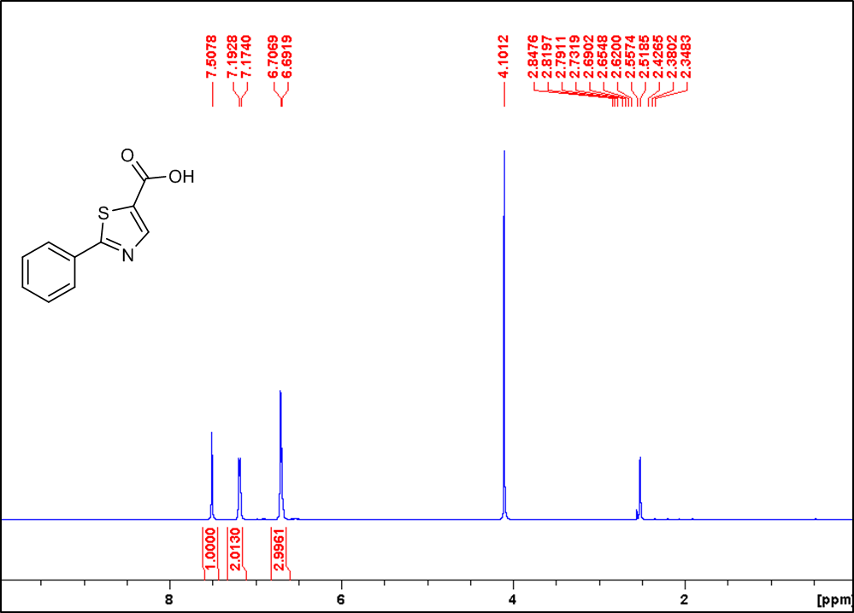

13C NMR of compound **§13** (ARW-220)

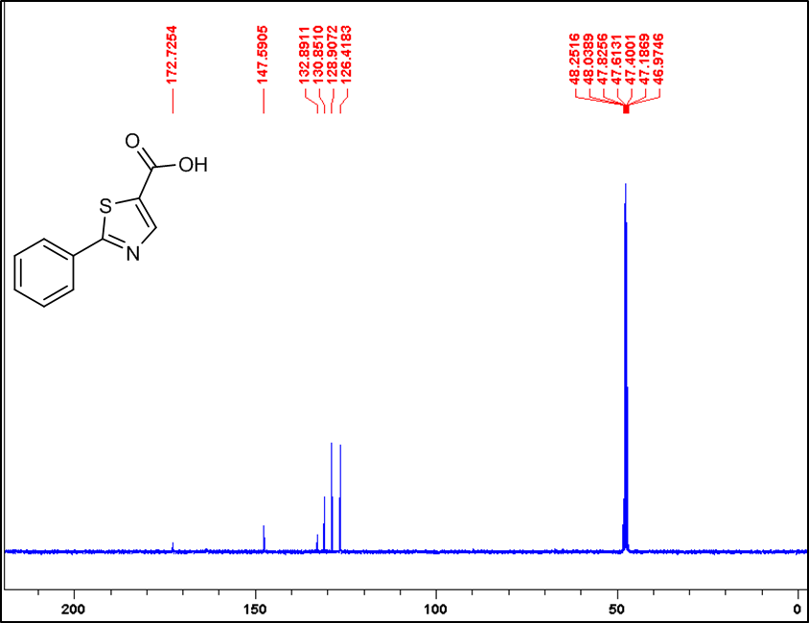

1H NMR of compound **§14 (NJ1-87cont)**



13C NMR of compound **§14 (NJ1-87cont)** 



1H NMR of compound **§15**

13C NMR of compound **§15**



1H NMR of compound **§16**

13C NMR of compound **§16**



1H NMR of compound **§17**

13C NMR of compound **§17**



1H NMR of compound **§18**

13C NMR of compound **§18**



1H NMR of compound **§19**

13C NMR of compound **§19**

1H NMR of compound **§20 (NJ1-71)**



13C NMR of compound **§20 (NJ1-71)**



1H NMR of compound **§21** (ARW-222)

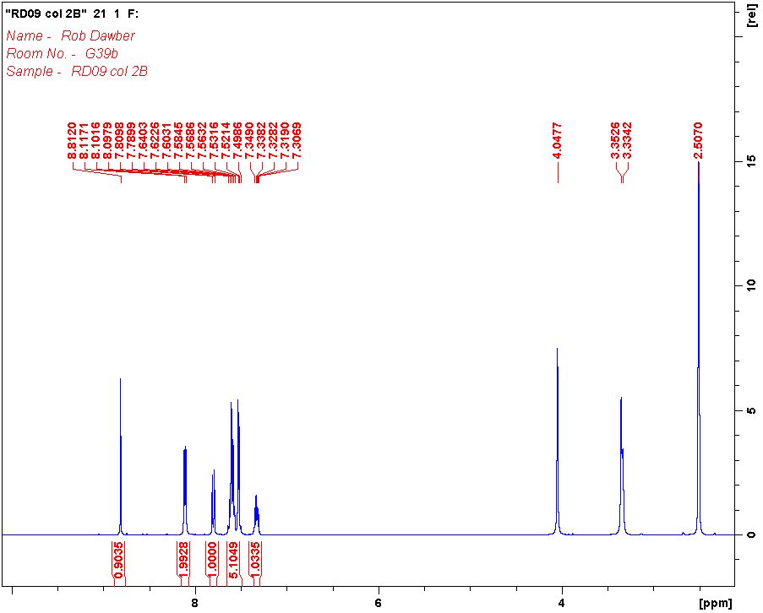

13C NMR of compound **§21** (ARW-222)

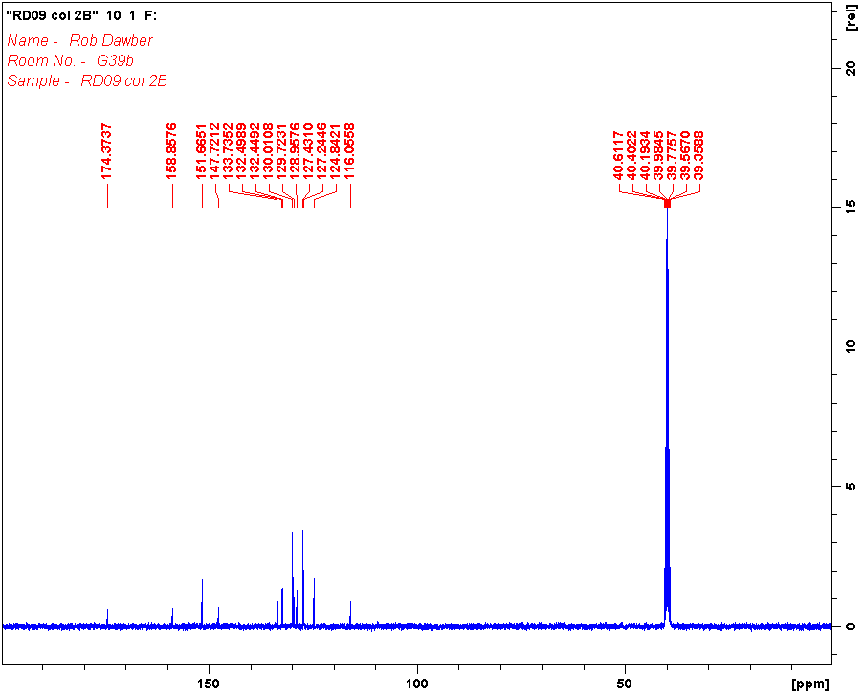

1H NMR of compound **§22 (NJ2-7)**



13C NMR of compound **§22 (NJ2-7)**



1H NMR of compound **§23 (OL-2rc)**



13C NMR of compound **§23 (OL-2rc)**



# **5. Mass spectra for ???**

Compound **§9a** (NJ1-19)

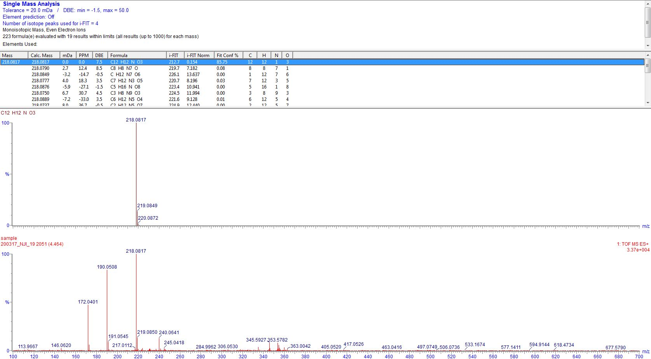

Compound **§9f** (DAP-16)

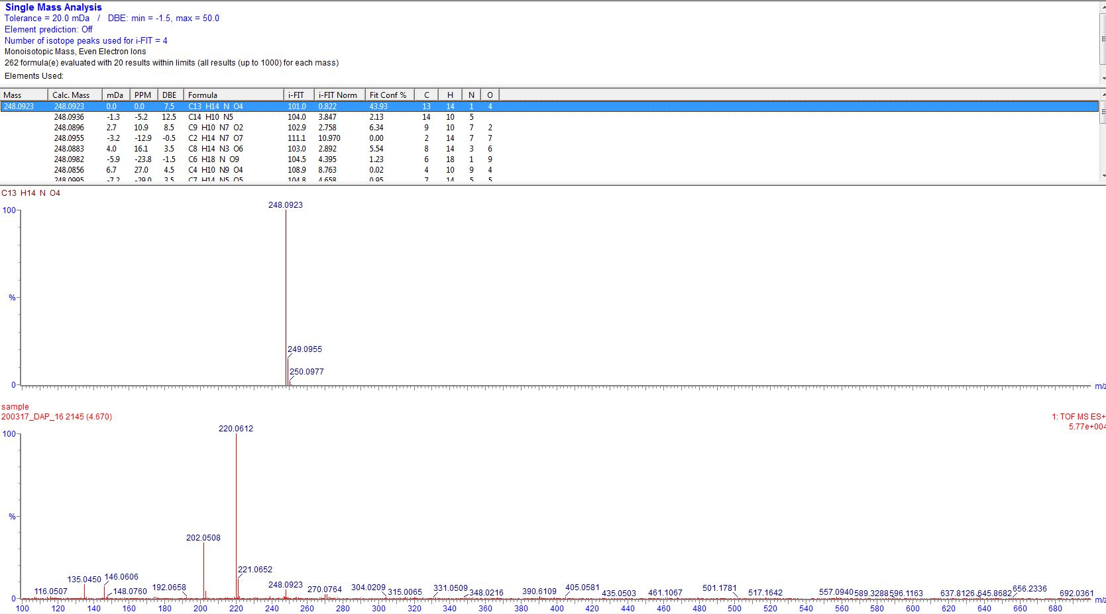

Compound **§9g** (DAP-10b)

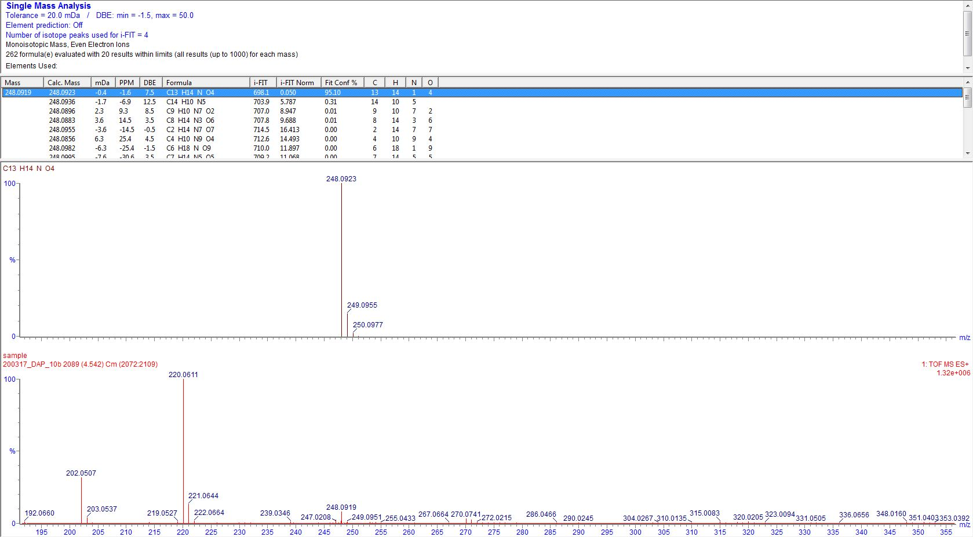

Compound **§9m** (NJ1-27)

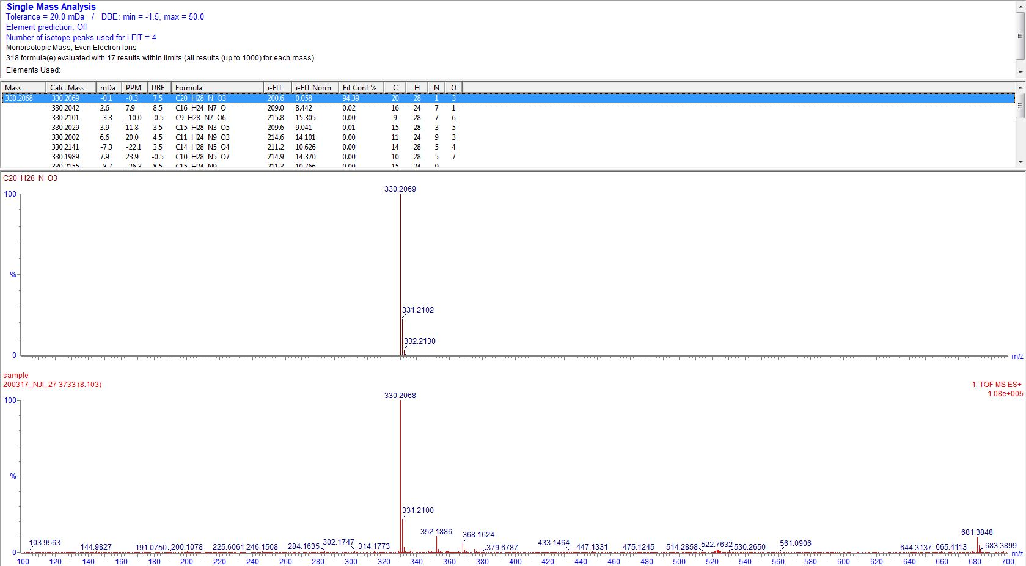

Compound **§9o** (NJ1-24)

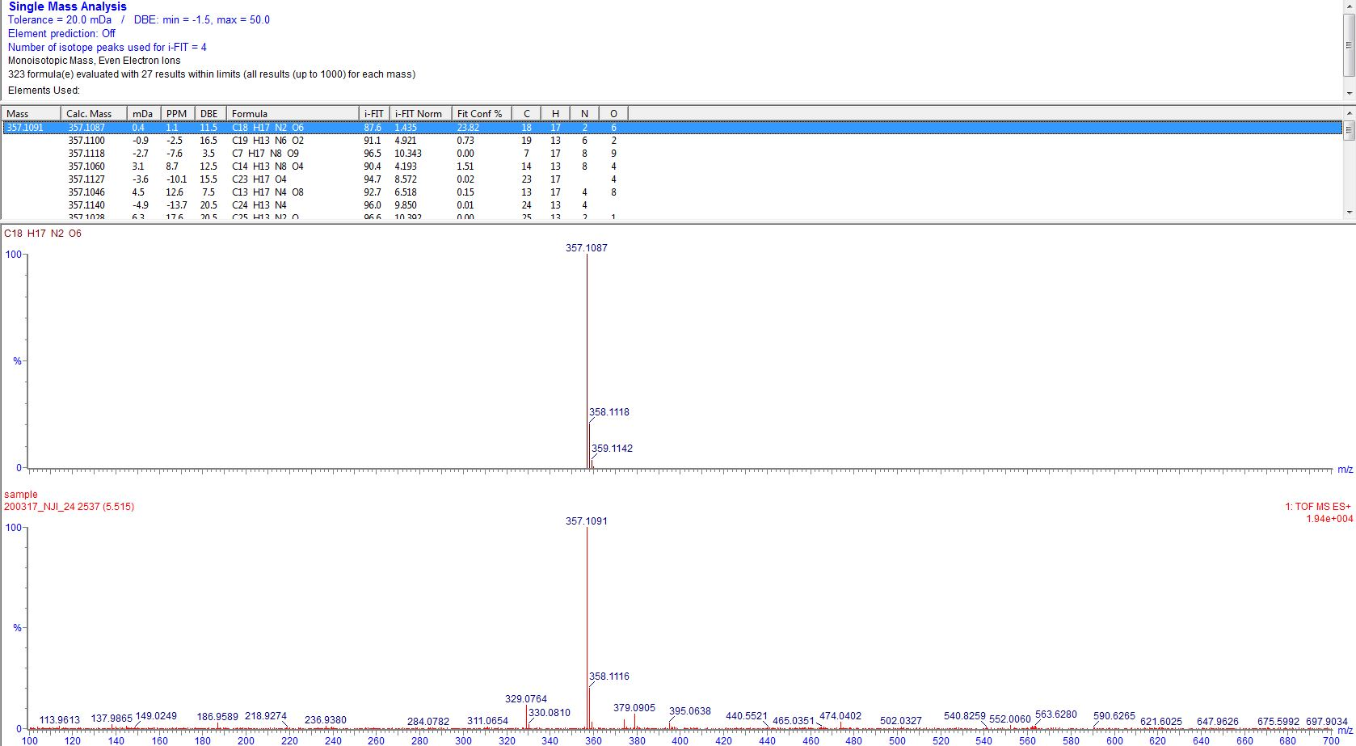

Compound **§10a** (NJ1-20)

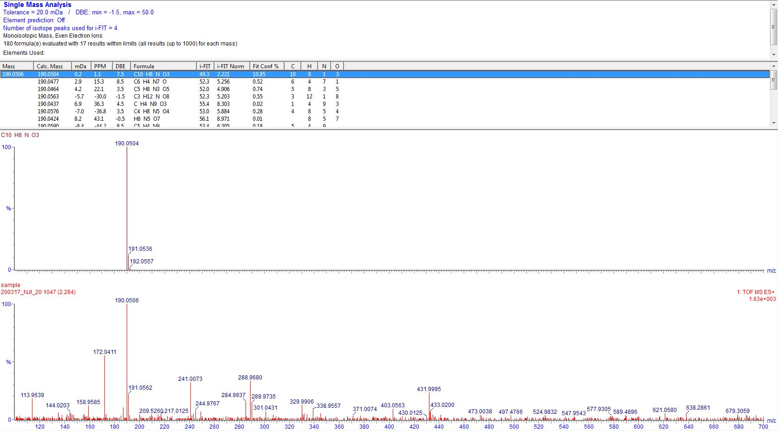

Compound **§10c** (DAP-06)

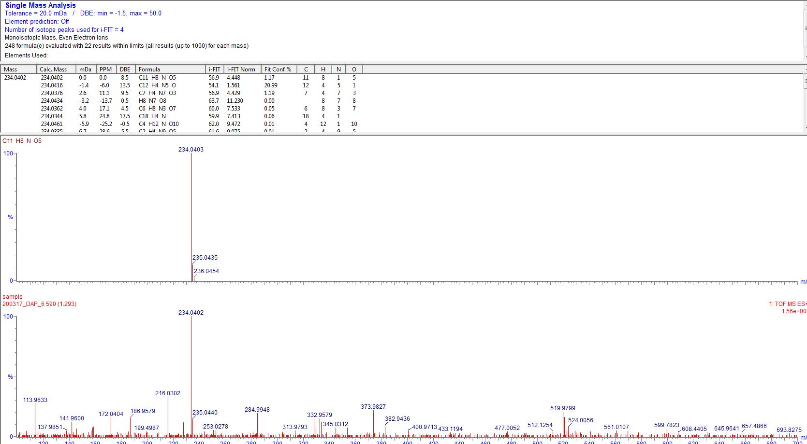

Compound **§10h** (NJ1-31)

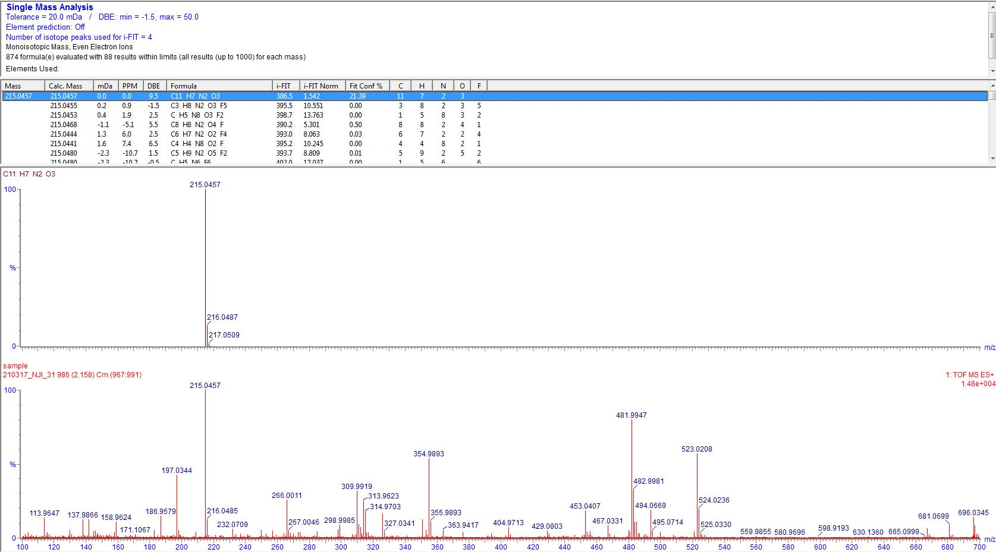

Compound **§10i** (NJ1-53)

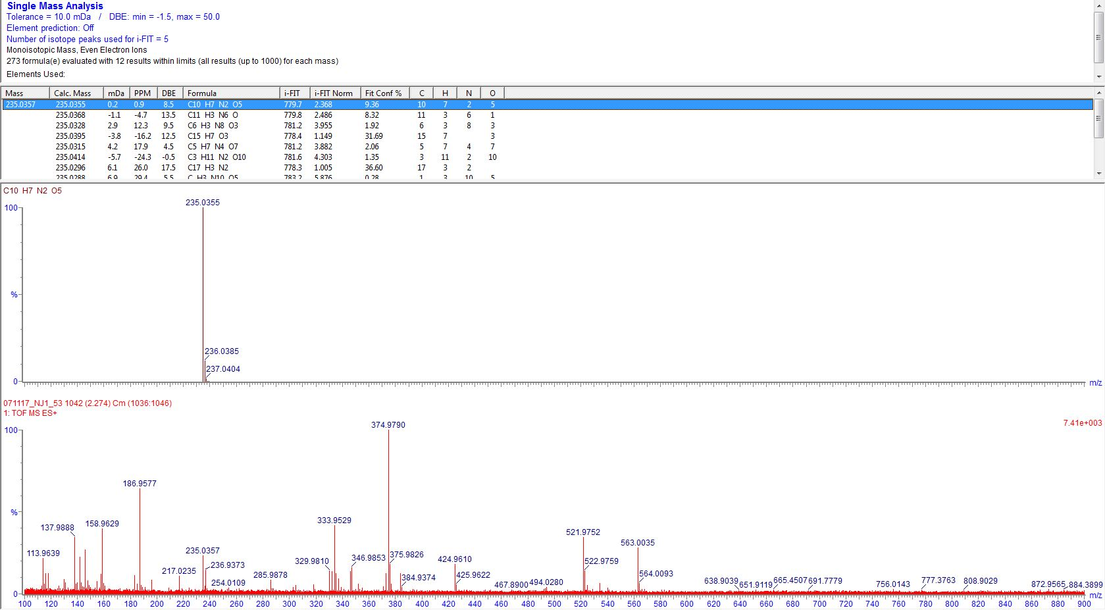

Compound **§10l** (NJ1-35)

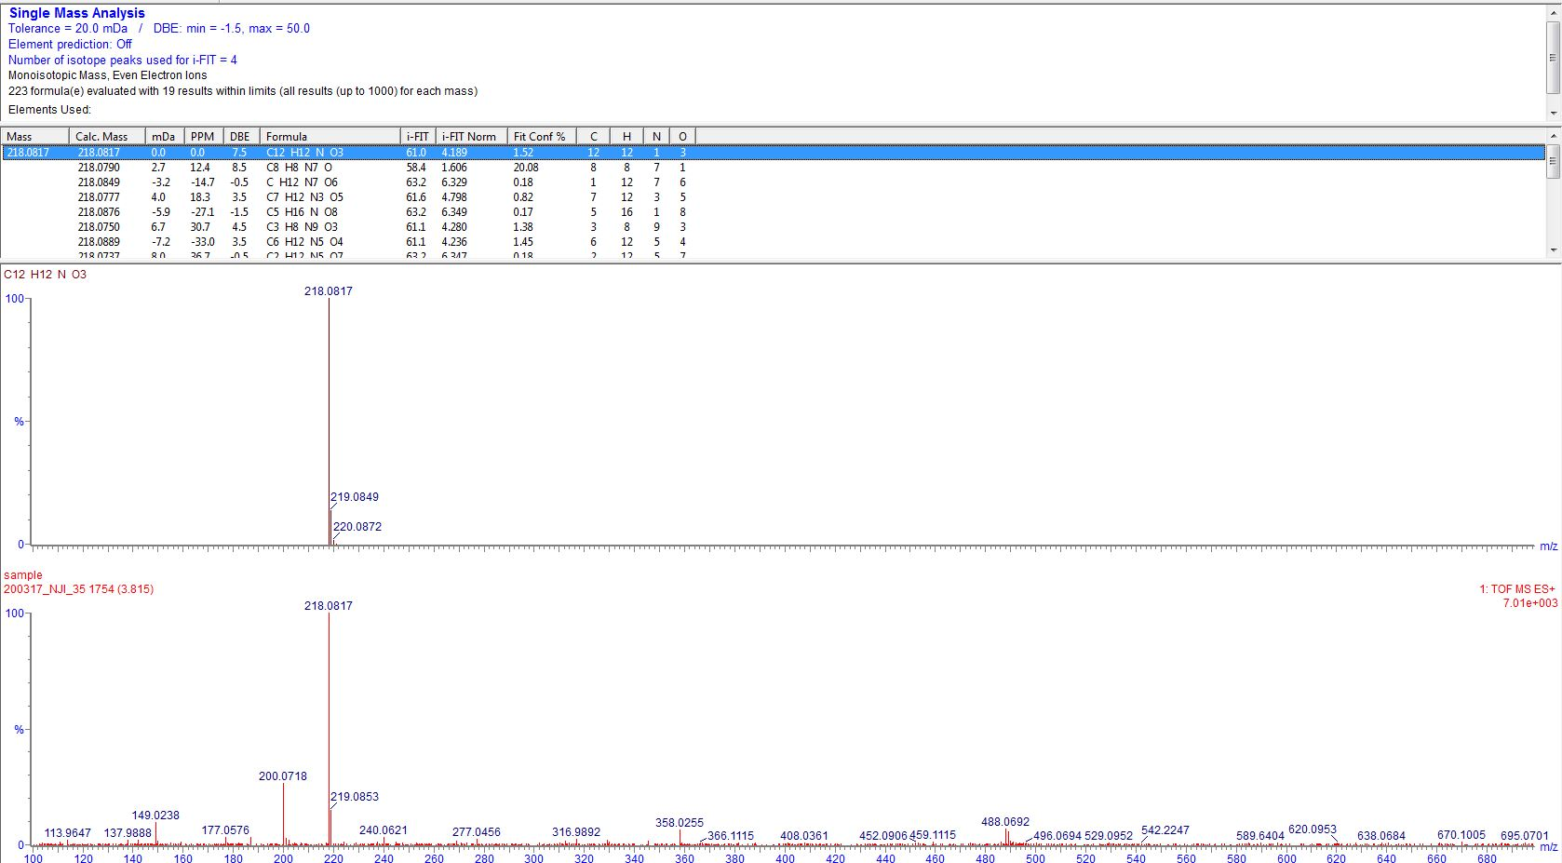

Compound **§10m** (NJ1-39)

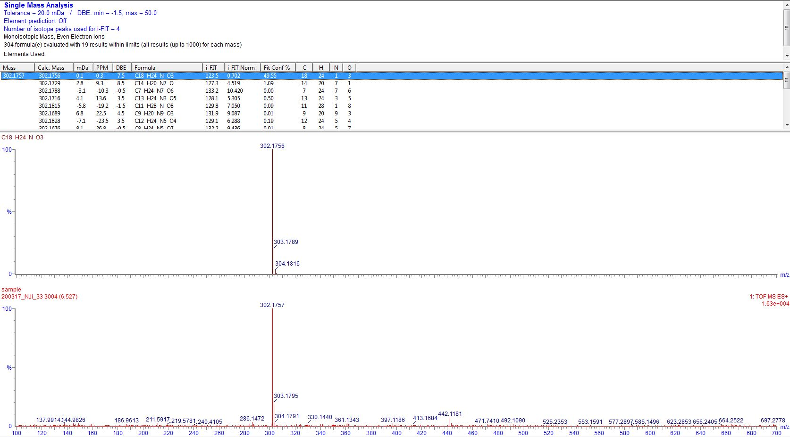

Compound **§10o** (NJ1-26)

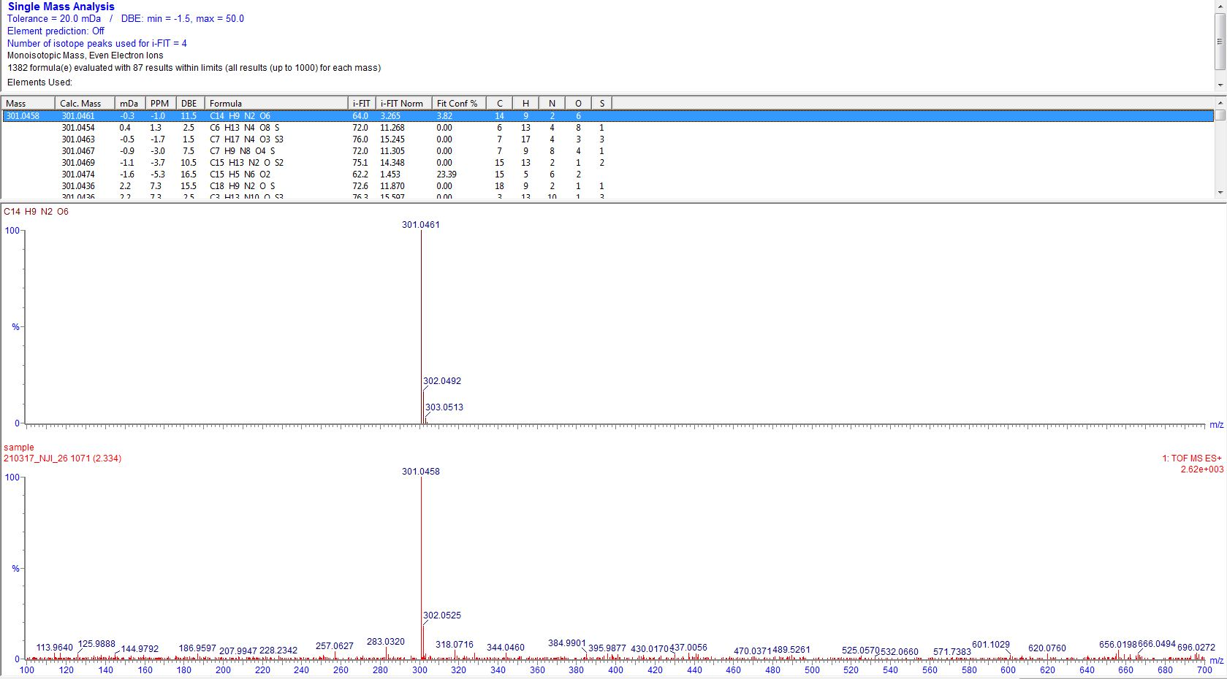

Compound **§11l** (NJ1-58)

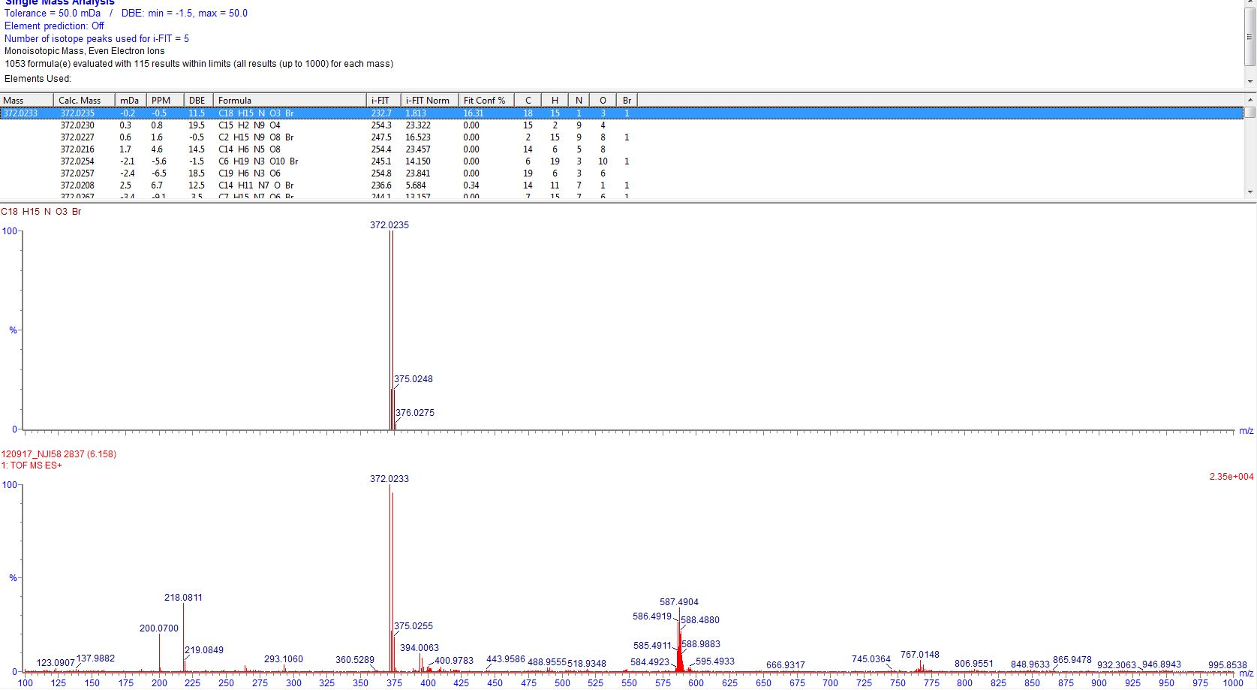

Compound **§11m** (NJ1-59)

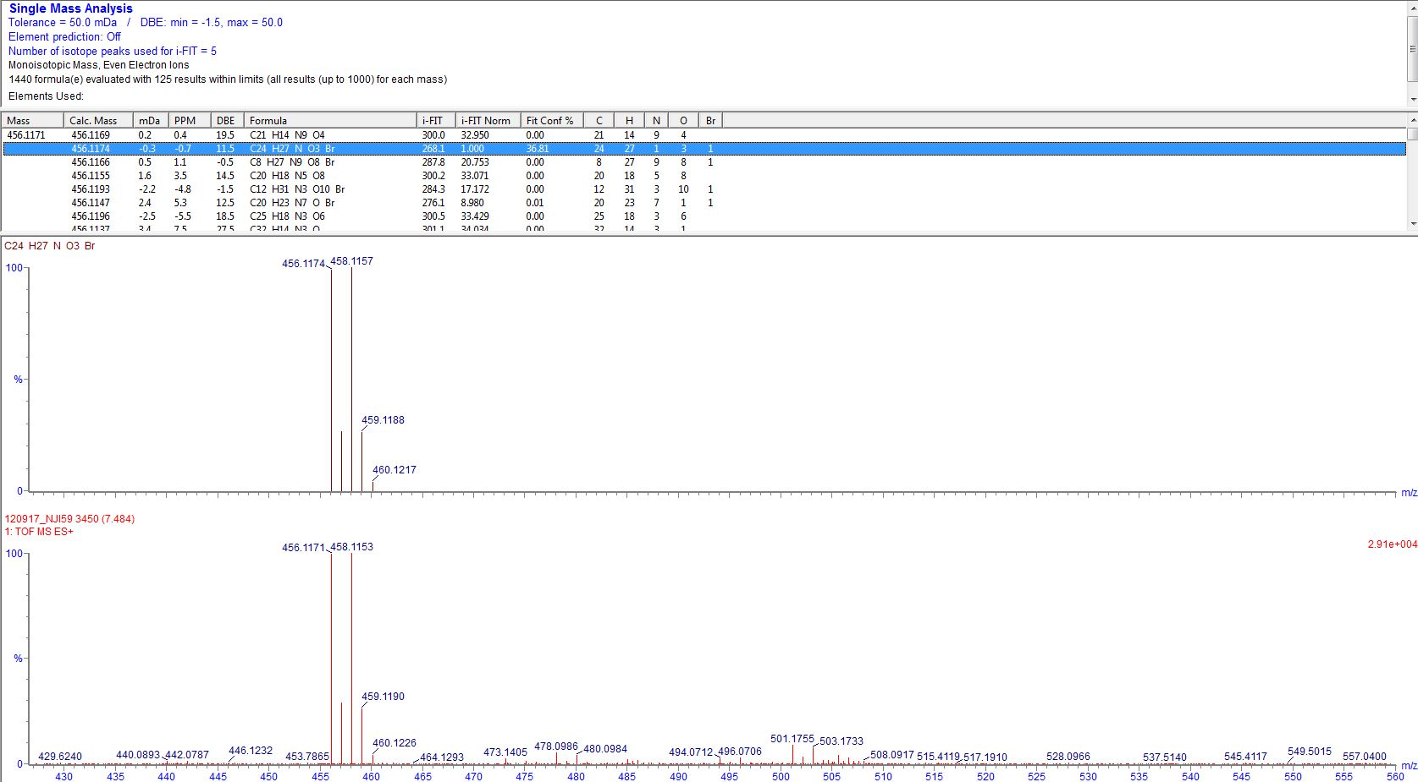

Compound **§12** (NJ1-32)

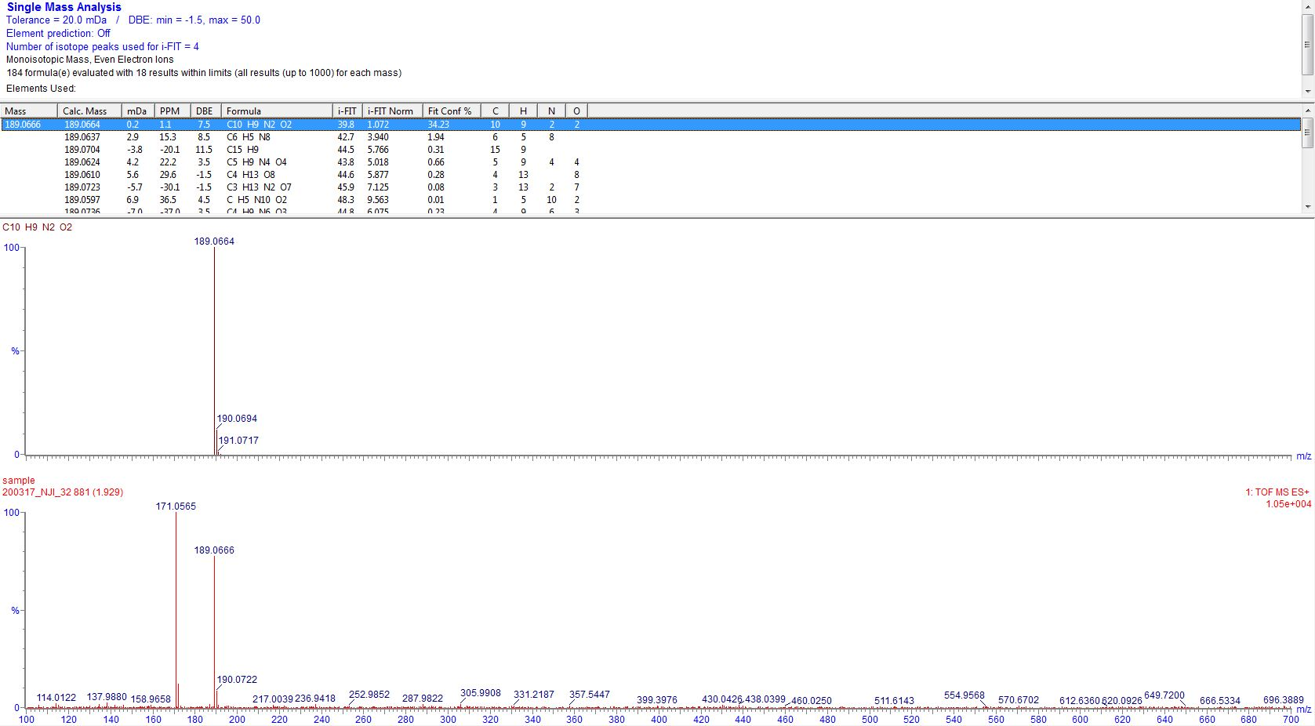

Compound **§14** (NJ1-87cont)

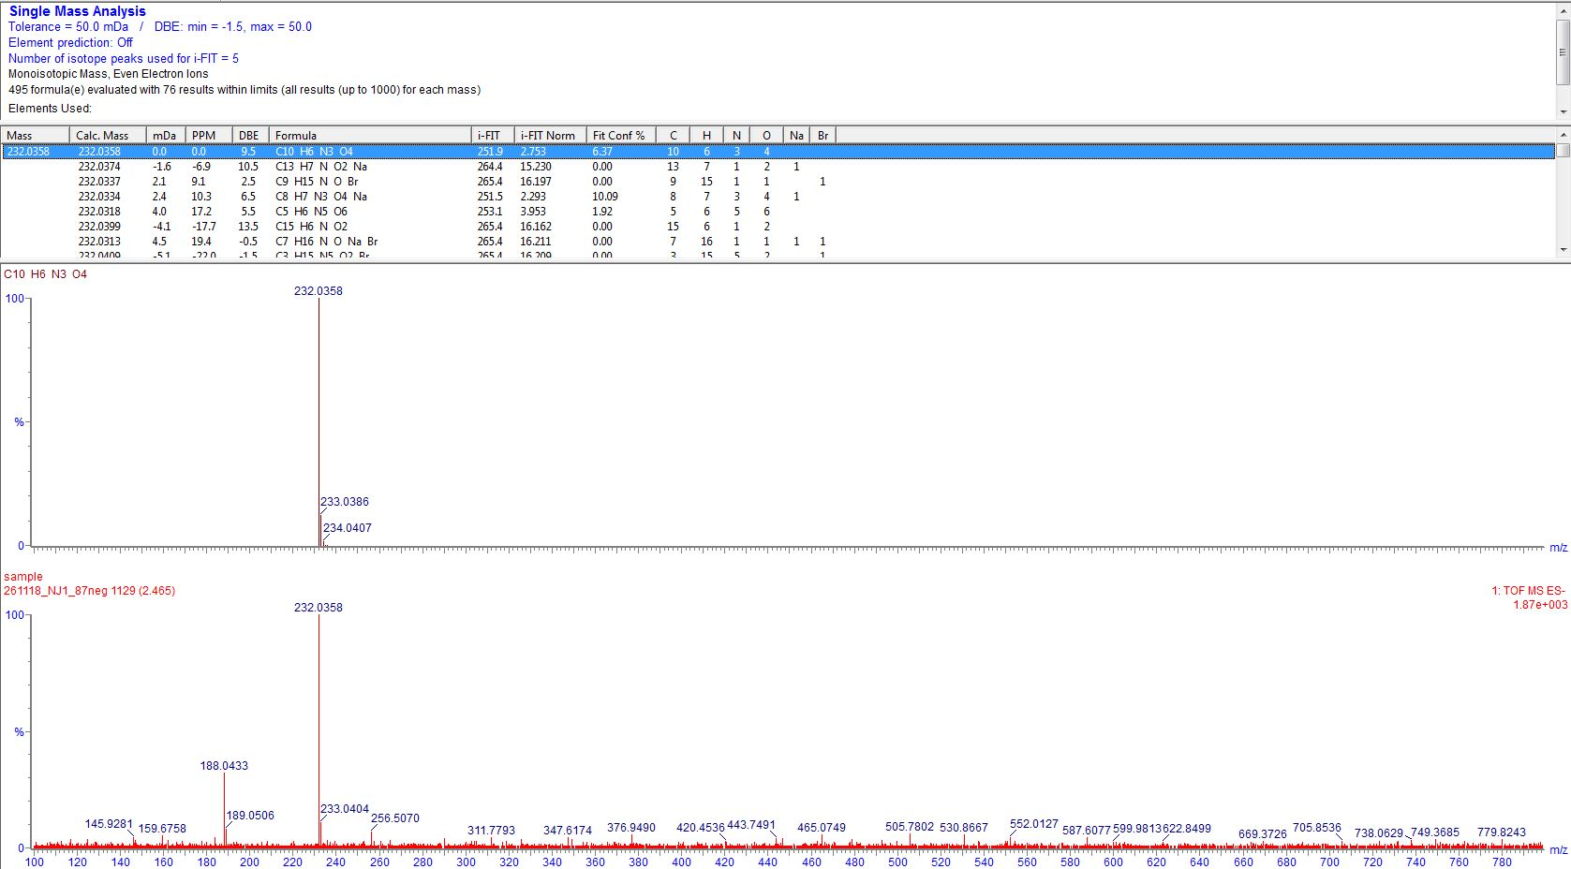

Compound **§20** (NJ1-71)

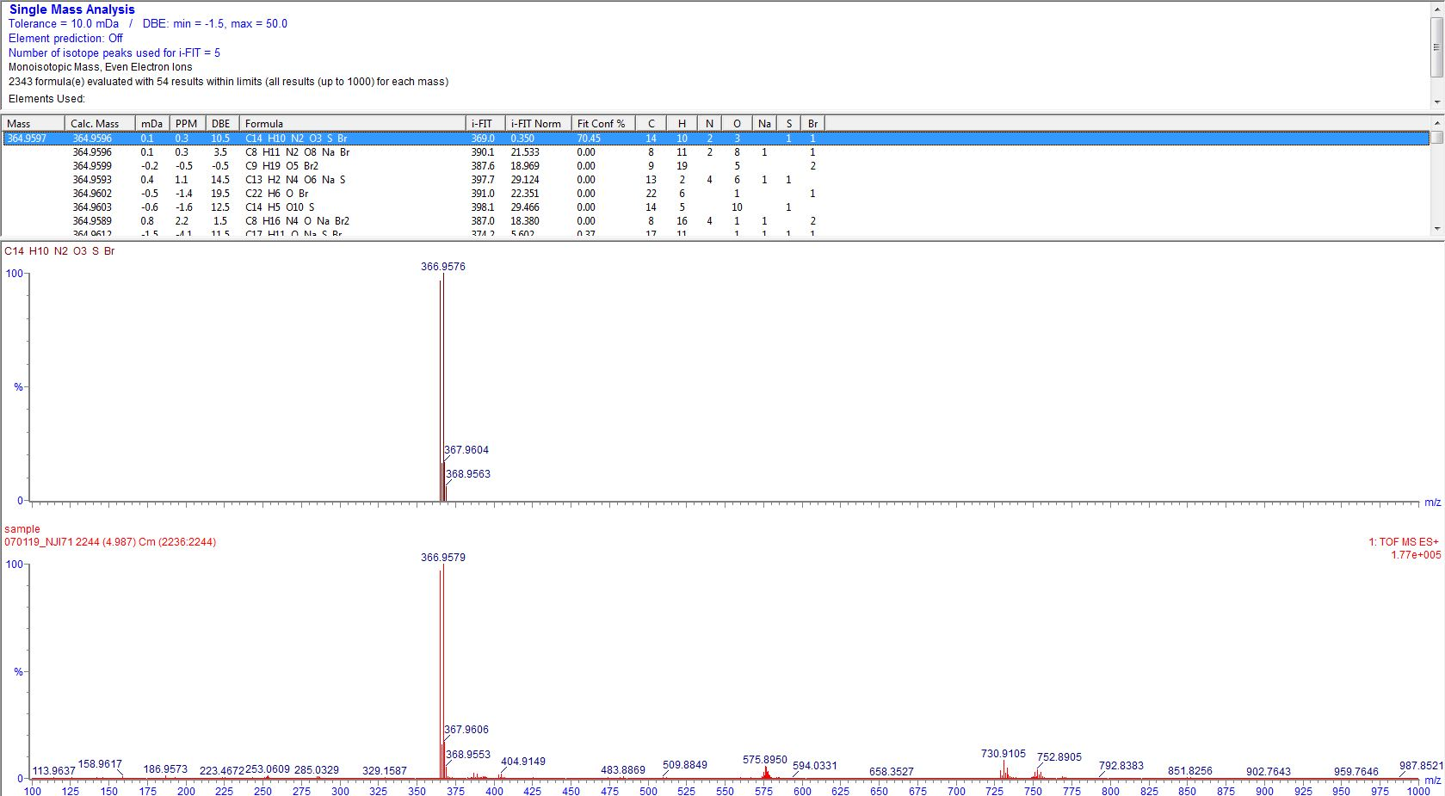

# **6. KNIME workflow**

KNIME workflow

# **X. References**

1. Grob (BMIDA)